***A SPECIMEN OF TITLE PAGE FOR MBA***

**A Summer Internship Project Report**

On

**Vehicle In Vehicle Out (VIVO)**

At/for



**TATA STEEL LTD.**

By

**SHUBHAM RAJ**

**PRN:1062232867**

MBA (Operations and Supply chain management)

Batch-2023-2025

Under the guidance of

**Prof. Dr. Sumanta Das**

Submitted to

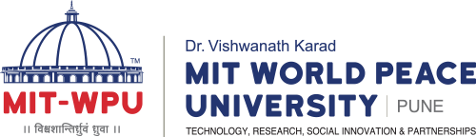

In partial fulfillment of the requirement for the award of Degree of Master in Business Administration (MBA)

**Submitted Through**

**MIT-WPU School of Business, Pune.**

**CERTIFICATE**

This is to certify that Mr. Shubham Raj of

MIT-WPU School of Business has successfully completed the project work titled

VEHICLE IN AND VEHICLE OUT (VIVO)

in partial fulfillment of the requirement for the award of MBAprescribed by the MIT World Peace University, Pune, from _03/06/202 to 26/08/2024.

This project is the record of authentic work carried out by him/her during the academic year_2023-2025__.

|  |  |  |
| --- | --- | --- |
| **Prof. Dr. Sumanta Das** | **Dr. Rajashree Kadam** | **Prof. Dr. Deependra Sharma** |
| **Internal Project Guide** | **Associate Dean** | **Dean** |
| **School of Business** | **School of Business** | **School of Business** |

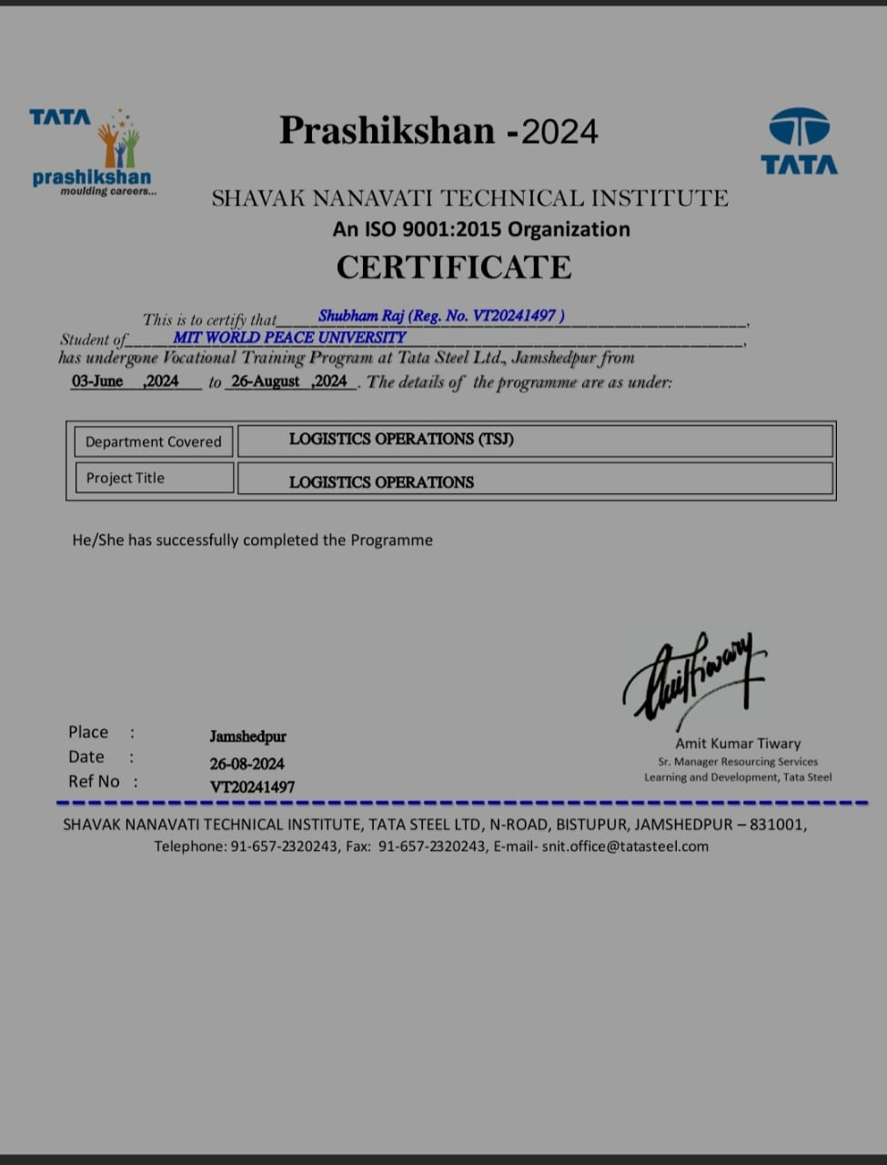

**DECLARATION**

I, Mr. SHUBHAM RAJ hereby declare that this project is the record of authentic work carried out by me during the academic year 2023-2025. This project is not been submitted to any other University or Institute towards the award of any degree.

Signature of the student

(SHUBHAM RAJ)

**INDEX**

|  |  |  |
| --- | --- | --- |
| **S. No.** | **Component** | **Page No** |
|  |  |  |
| 1 | Abstract | 6-11 |
| 2 | Introduction to company and research problem OR Job description and research problem | 12-34 |
| 3 | Literature review/Theoretical framework | 35-41 |
| 4 | Research Methodology | 42-53 |
| 5 | Analysis of findings | 54-68 |
| 6 | Conclusions and Suggestions | 69-73 |
| 7 | references | 74 |

# ABSTRACT

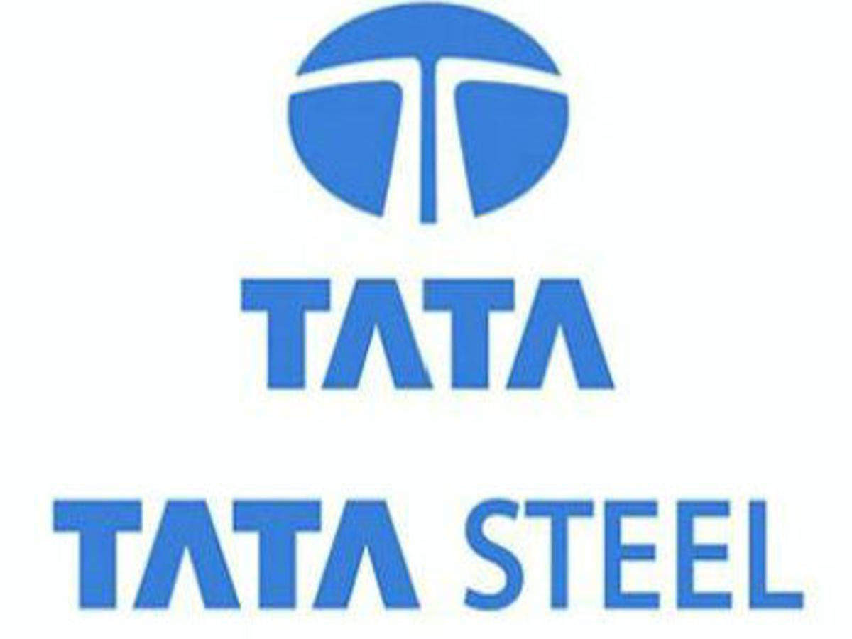

r This internship report explores the management of vehicle movement at Tata Steel, focusing on the tracking and optimization of vehicles entering and exiting the premises. Tata Steel, as a leading global steel producer, operates multiple facilities with significant transportation needs. Efficient management of vehicle traffic is crucial for ensuring operational efficiency, safety, and environmental sustainability.

The report begins with an overview of Tata Steel's operations and the importance of effective vehicle management. It then delves into the methods and technologies employed to monitor and control vehicle movement, including GPS tracking, RFID systems, and automated gate control mechanisms.

Key aspects covered include:

* **System Architecture**: Description of the technological infrastructure supporting vehicle tracking and management.
* **Data Collection and Analysis**: Methods used to gather and analyze data on vehicle movement patterns, including peak times, route optimization, and resource allocation.
* **Challenges and Solutions**: Identification of challenges faced in managing vehicle traffic and proposed solutions to enhance efficiency and reduce operational costs.
* **Environmental Impact**: Assessment of the environmental impact of vehicle operations and measures taken to mitigate carbon footprint.

The internship provided practical insights into the complexities of managing a large-scale industrial facility's transportation logistics. It underscored the importance of leveraging technology and data analytics to optimize processes and improve overall operational performance.

This abstract should give a clear overview of what the internship report entails, focusing on the specific aspects related to Tata Steel's vehicle management system. Adjustments can be made based on the specific findings and emphasis of your internship experience.

Tata Steel's Jamshedpur plant, a major industrial hub in India, is known for its diverse range of steel products and cutting-edge technologies. When it comes to the concept of "abstract vehicles" in the context of Tata Steel, there are a few interpretations:

1. **Innovative Applications of Steel in Vehicle Design**: Tata Steel might be involved in creating advanced steel components used in the design of various vehicles. These components could include lightweight alloys, high-strength steel, or specialized coatings that enhance vehicle performance, safety, and efficiency. The "abstract" part could refer to conceptual or prototype designs that push the boundaries of conventional vehicle engineering.
2. **Steel Infrastructure for Vehicle Manufacturing**: Tata Steel’s products might be used in the infrastructure and machinery supporting vehicle production. This could include advanced materials for factory equipment, automated systems, or structural elements in manufacturing plants.
3. **Sustainable and Future-Oriented Concepts**: Tata Steel might be engaged in research and development of new steel technologies that contribute to the future of automotive design. This could involve sustainable practices, recycling initiatives, or new alloys that help create more eco-friendly or efficient vehicles.
4. **Artistic or Conceptual Representations**: "Abstract vehicles" might also refer to artistic or conceptual representations of vehicles in steel, created as part of an art installation or design project. Tata Steel’s involvement could be in providing the materials or collaborating on such innovative projects.

If you’re looking for specific projects or collaborations involving Tata Steel and vehicle design, there might be detailed information available through their corporate communications or industry reports.

Top of Form

Bottom of Form

Tata Steel's Jamshedpur plant is renowned for its historical significance and cutting-edge contributions to the steel industry. The concept of "abstract vehicles" in the context of Tata Steel can be explored through several dimensions, emphasizing the plant's role in advancing vehicle technology, infrastructure, sustainability, and innovative design.

**Innovative Steel Applications in Vehicle Design**

Tata Steel is a key player in the global steel industry, providing a broad spectrum of products that cater to various sectors, including automotive. In vehicle design, steel plays a pivotal role in ensuring safety, performance, and efficiency. Tata Steel’s research and development teams are engaged in creating advanced steel alloys and composites that are crucial for modern vehicle manufacturing. These innovations might include:

* **High-Strength Low-Alloy (HSLA) Steels**: These materials are engineered to offer superior strength and durability while maintaining a lower weight compared to conventional steels. HSLA steels are critical for automotive applications where reducing vehicle weight can enhance fuel efficiency and reduce emissions.
* **Advanced High-Strength Steels (AHSS)**: These steels are designed to provide even greater strength and are often used in the structure of vehicles to enhance crashworthiness and safety. Tata Steel’s involvement in developing AHSS could lead to new standards in vehicle safety and performance.
* **Coated Steels**: Protective coatings can significantly enhance the lifespan of steel components exposed to harsh environmental conditions. Tata Steel’s innovations in coatings could improve vehicle longevity and reduce maintenance costs.

**Steel Infrastructure for Vehicle Manufacturing**

The Jamshedpur plant’s contributions extend beyond just producing steel for vehicles. Steel is integral to the infrastructure and machinery used in vehicle manufacturing. Tata Steel’s expertise in creating robust and reliable steel products can impact several facets of the automotive production process:

* **Manufacturing Equipment**: Steel is a fundamental material in the construction of machinery used in vehicle assembly lines. The strength and reliability of this equipment are crucial for maintaining high production standards and efficiency.
* **Factory Construction**: The structural integrity of manufacturing plants depends on high-quality steel. Tata Steel’s products can contribute to building and maintaining the infrastructure required for large-scale vehicle production.
* **Logistics and Transport**: Steel components are essential in the logistics of transporting raw materials and finished vehicles. Tata Steel’s innovations in steel products can enhance the durability and efficiency of transport systems.

**Sustainable and Future-Oriented Concepts**

Sustainability is a critical concern in modern manufacturing, including the automotive sector. Tata Steel’s commitment to sustainability is reflected in their initiatives to develop eco-friendly steel solutions and promote recycling. This includes:

* **Recycled Steel**: Utilizing recycled steel reduces the environmental impact associated with raw material extraction and processing. Tata Steel’s advancements in recycling technology contribute to a circular economy in the automotive industry.
* **Energy Efficiency**: Reducing the energy consumption of steel production is another focus area. By adopting more energy-efficient practices and technologies, Tata Steel helps lower the overall carbon footprint of vehicle manufacturing.
* **Sustainable Vehicle Components**: Innovations in steel technology can lead to the development of components that are not only lighter and stronger but also more environmentally friendly. This aligns with the broader goals of reducing vehicle emissions and enhancing overall sustainability.

**Artistic and Conceptual Representations**

Beyond practical applications, steel can also be used in artistic and conceptual representations of vehicles. Tata Steel’s involvement in such projects highlights the versatility of steel and its potential for creative expression:

* **Art Installations**: Steel sculptures or installations that depict abstract vehicles can serve as a medium for artistic exploration. These projects can showcase the aesthetic potential of steel and its role in shaping modern design.
* **Design Prototypes**: Abstract vehicle designs might explore new forms and concepts that challenge traditional automotive aesthetics. Tata Steel’s materials could be used in these prototypes to push the boundaries of vehicle design.
* **Collaborations with Designers**: Working with industrial designers and artists, Tata Steel can contribute to innovative projects that blend technology, art, and vehicle design, offering new perspectives on how steel can be used creatively.

In conclusion, Tata Steel’s Jamshedpur plant plays a multifaceted role in the development of vehicle technologies, infrastructure, sustainability, and creative design. By continuously innovating and applying their expertise in steel production, Tata Steel supports advancements across various dimensions of the automotive industry, from practical applications to artistic endeavours.

In the contemporary automotive industry, there is an increasing demand for materials that offer superior performance, safety, and sustainability. At the forefront of meeting these needs, Tata Steel Jamshedpur is spearheading innovative research to develop advanced steel solutions tailored specifically for automotive applications. This research aims to address key challenges including enhancing vehicle performance, improving safety standards, and aligning with global sustainability goals.

**Objective**

The primary objective of this research is to develop and implement advanced steel technologies that meet the evolving requirements of the automotive industry. This involves exploring new steel alloys, refining processing techniques, and integrating sustainable practices into steel production and automotive applications. By leveraging Tata Steel’s expertise and resources, the research seeks to deliver high-performance steel solutions that contribute to the future of automotive design and manufacturing.

**Research Design**

The research methodology is designed to encompass a comprehensive approach that includes exploratory research, experimental work, applied research, and sustainability assessment:

1. **Exploratory Research:**
   * **Market and Technology Scanning:** Identifying emerging trends, technological advancements, and industry needs through detailed literature reviews, market analysis, and regulatory reviews.
   * **Literature Synthesis:** Reviewing academic papers, patents, and industry reports to develop a theoretical framework that guides subsequent research phases.
2. **Experimental Research:**
   * **Alloy Development:** Creating new steel alloys with enhanced properties such as increased strength, reduced weight, and improved corrosion resistance through computational modeling and laboratory testing.
   * **Processing Techniques:** Refining manufacturing techniques like hot stamping and induction hardening to optimize steel processing parameters and product quality.
   * **Prototype Development and Testing:** Fabricating prototypes and conducting performance tests including crash simulations and durability assessments to validate the effectiveness of new steel solutions.
3. **Applied Research:**
   * **Industry Collaboration:** Partnering with automotive manufacturers to integrate new steel technologies into vehicle designs and production processes, followed by pilot production runs and real-world testing.
   * **Real-World Testing:** Evaluating the performance of new steel components under actual driving conditions and gathering feedback from industry partners to refine and enhance the technologies.
4. **Sustainability Research:**
   * **Lifecycle Assessment (LCA):** Conducting comprehensive LCA to evaluate the environmental impact of new steel technologies, including energy consumption, emissions, and resource utilization.
   * **Circular Economy and Recycling:** Investigating recycling methods and strategies to support a circular economy, aiming to reduce waste and improve resource efficiency.

**Data Collection and Analysis**

The research employs a multifaceted approach to data collection and analysis:

* **Literature Review:** Comprehensive searches of academic and industry sources to gather and synthesize relevant information.
* **Laboratory Experiments:** Systematic testing of steel samples to assess mechanical properties and microstructural characteristics.
* **Pilot Production Runs:** Production of prototypes and collection of data on production efficiency and product quality.
* **Field Trials:** Real-world testing of new steel components in vehicles to assess performance and durability.
* **Sustainability Assessments:** Analysis of environmental impact through LCA and evaluation of recycling potential.

Data analysis involves statistical methods, material characterization techniques, and feedback analysis to draw meaningful conclusions and guide the development of advanced steel solutions.

**Expected Outcomes**

The research is expected to yield several significant outcomes:

* **Enhanced Steel Technologies:** Development of steel alloys and processing techniques that offer improved performance, safety, and durability for automotive applications.
* **Successful Integration:** Effective integration of new steel solutions into automotive manufacturing processes, demonstrating practical benefits and feasibility.
* **Sustainable Practices:** Implementation of eco-friendly practices and circular economy principles to minimize environmental impact and promote sustainability.
* **Industry Advancements:** Contributions to the automotive industry through innovative steel technologies that address current and future challenges.

**Conclusion**

Tata Steel Jamshedpur's research into advanced steel solutions for automotive applications is poised to make a substantial impact on the industry. By combining cutting-edge technology development with rigorous testing and sustainability assessment, the research aims to deliver high-performance, safe, and environmentally-friendly steel solutions. This comprehensive approach will not only advance automotive steel technology but also support the broader goals of sustainability and industry innovation, reinforcing Tata Steel’s position as a leader in materials science and automotive engineering.

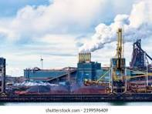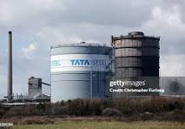Top of Form

Bottom of Form

Top of Form

Bottom of Form

value system is not an adjunct to profits, but forms the very core around which  
each Tata group company works to create long-term stakeholder value based

# INTRODUCTION

*Tata Steel Overview:* Tata Steel, renowned globally as a leading steel producer, operates extensive facilities with significant transportation requirements. The efficient management of vehicle traffic within these facilities is critical for maintaining operational productivity, safety standards, and environmental sustainability. As such, understanding and optimizing the movement of vehicles in and out of Tata Steel premises is a paramount concern.

*Research Problem:* The research problem at hand revolves around enhancing the management of vehicle movements at Tata Steel. Specifically, the challenge lies in improving the tracking, monitoring, and efficiency of vehicles entering and exiting the premises. This includes addressing issues such as congestion during peak hours, ensuring compliance with safety protocols, optimizing route planning, and minimizing environmental impact.

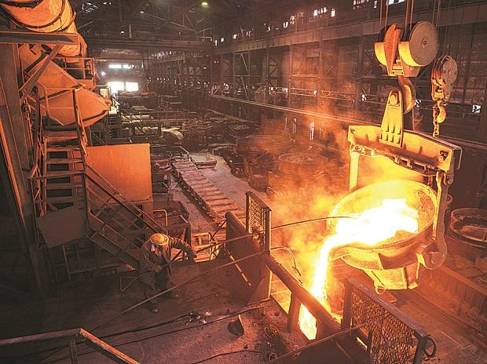

From an early foray into steel and automobiles, to staying abreast of the latest  
technologies, the Tata group is present in 150 countries and six continents.  
It operates through 30 companies that are segregated into 10 clusters.

Automotive

**AUTOMOTIVE**

Automotive

**STEEL**

Automotive

**INFORMATION TECHNOLOGY**

Automotive

**CONSUMER AND RETAIL**

Automotive

**INFRASTRUCTURE**

Automotive

**TELECOMMUNICATION & MEDIA**

Automotive

**TRADING AND INVESTMENTS**

Automotive

**FINANCIAL SERVICES**

Automotive

**TOURISM AND TRAVEL**

Automotive

**AEROSPACE AND DEFENCE**

**Tata Steel, one of the largest steel producers globally, has a long-standing tradition of innovation and excellence, with its Jamshedpur plant being a cornerstone of its operations. Established in 1907, the Jamshedpur plant is renowned not only for its high-quality steel production but also for its pivotal role in various industries, including the automotive sector.**

**The concept of "vehicles" emerging from Tata Steel Jamshedpur encompasses a diverse range of applications and innovations. Tata Steel’s contributions to vehicle technology and manufacturing extend from the materials used in vehicle construction to the infrastructure supporting vehicle production. This synergy of steel and automotive engineering highlights Tata Steel’s role in advancing vehicle technology and design, ensuring that vehicles are safer, more efficient, and environmentally friendly.**

**Steel’s Role in Automotive Engineering**

**The automotive industry relies heavily on steel for various components and structural elements. Tata Steel’s Jamshedpur plant plays a crucial role in supplying high-quality steel that meets the stringent requirements of modern vehicles. The steel produced at Jamshedpur is integral to several key aspects of vehicle design:**

1. **Structural Integrity and Safety: Modern vehicles require high-strength materials to ensure passenger safety and structural integrity. Tata Steel produces advanced high-strength steels (AHSS) and high-strength low-alloy (HSLA) steels that are essential for manufacturing vehicle frames, crash structures, and other critical components. These materials provide the strength necessary to withstand impact forces and protect occupants in the event of a collision.**
2. **Weight Reduction and Fuel Efficiency: Reducing vehicle weight is crucial for enhancing fuel efficiency and reducing emissions. Tata Steel’s innovations in lightweight steel alloys help manufacturers design vehicles that are both strong and light, improving overall performance and sustainability.**
3. **Durability and Corrosion Resistance: Vehicles are exposed to harsh environmental conditions, making durability and corrosion resistance essential. Tata Steel offers various coated steels that provide enhanced protection against rust and deterioration, contributing to the longevity and reliability of vehicles.**

**Infrastructure and Manufacturing Support**

**Beyond the steel used in vehicles themselves, Tata Steel’s Jamshedpur plant contributes significantly to the infrastructure supporting vehicle manufacturing:**

1. **Manufacturing Equipment: The production of vehicles involves complex machinery and equipment that require robust steel components. Tata Steel’s high-quality materials are used in the construction of machinery and tools essential for vehicle assembly and production.**
2. **Factory Construction: The design and construction of vehicle manufacturing facilities rely on strong and durable steel structures. Tata Steel provides the structural steel necessary for building and maintaining these facilities, ensuring they meet the operational demands of large-scale vehicle production.**
3. **Logistics and Transportation: Steel plays a key role in the logistics of transporting raw materials and finished vehicles. Tata Steel’s products contribute to the durability and efficiency of transport systems, facilitating the movement of components and completed vehicles across various stages of the supply chain.**
4. 

**Sustainability and Future Innovations**

**Tata Steel is committed to advancing sustainability in steel production and vehicle manufacturing:**

1. **Recycling and Eco-Friendly Steel: Tata Steel’s focus on recycling and using eco-friendly steel products helps reduce the environmental impact of steel production. By integrating recycled materials and sustainable practices, Tata Steel supports the automotive industry’s efforts to minimize its ecological footprint.**
2. **Energy Efficiency: Innovations in steel production technology at Tata Steel aim to reduce energy consumption and greenhouse gas emissions. These advancements contribute to more sustainable vehicle manufacturing processes.**
3. **Future-Oriented Steel Solutions: Tata Steel’s ongoing research and development efforts are directed towards creating new steel technologies that support the future of automotive design. This includes exploring new alloys, coatings, and production methods that align with the evolving needs of the automotive industry.**

**Artistic and Conceptual Contributions**

**In addition to practical applications, Tata Steel’s involvement in artistic and conceptual vehicle designs demonstrates the versatility of steel:**

1. **Design Prototypes: Tata Steel collaborates with designers to develop abstract and innovative vehicle prototypes. These projects explore new forms and concepts, pushing the boundaries of traditional vehicle design and showcasing the creative potential of steel.**
2. **Artistic Installations: Steel sculptures and installations inspired by vehicle designs highlight the artistic possibilities of steel. Tata Steel’s materials are used in these works to combine functionality with artistic expression, creating unique and thought-provoking representations of vehicles.**

**Steel’s Role in Modern Vehicle Design**

**The automotive industry relies heavily on steel for a wide range of applications, and Tata Steel’s contributions are integral to several aspects of vehicle design and manufacturing. The company’s innovations in steel technology have significant impacts on vehicle safety, performance, and efficiency:**

**1. Structural Integrity and Safety**

**In modern vehicles, structural integrity is paramount for ensuring passenger safety. Tata Steel’s advanced high-strength steels (AHSS) and high-strength low-alloy (HSLA) steels are crucial in this regard. These materials are designed to withstand high stress and impact forces, thereby enhancing the vehicle's ability to absorb crash energy and protect occupants.**

* **High-Strength Steels (HSS): These steels are engineered to be both strong and lightweight, allowing for more efficient use of materials without compromising safety. Tata Steel’s HSS products help manufacturers design vehicle frames and safety cells that meet rigorous safety standards while minimizing weight.**
* **Advanced High-Strength Steels (AHSS): AHSS offers even greater strength and ductility compared to standard high-strength steels. This technology is used in critical components such as crash zones and reinforcements, providing enhanced protection in the event of a collision.**

**2. Weight Reduction and Fuel Efficiency**

**Reducing vehicle weight is a key strategy for improving fuel efficiency and reducing emissions. Tata Steel’s innovations in lightweight steel alloys play a crucial role in achieving these goals. By using advanced steels that provide high strength with reduced weight, vehicle manufacturers can enhance fuel economy and lower carbon footprints.**

* **Lightweight Alloys: Tata Steel’s research into lightweight steel alloys helps create components that are strong yet lighter than traditional materials. This reduction in weight contributes to better vehicle performance and increased fuel efficiency.**
* **Innovative Design Solutions: Tata Steel collaborates with automotive designers to develop innovative solutions that integrate lightweight steels into vehicle structures. These solutions include optimized designs that balance strength and weight for improved overall efficiency.**

**3. Durability and Corrosion Resistance**

**Vehicles are subject to harsh environmental conditions, making durability and corrosion resistance essential. Tata Steel offers a range of coated steels designed to protect against rust and deterioration, which extends the lifespan of vehicle components and reduces maintenance needs.**

* **Coated Steels: Tata Steel’s coated steels, such as galvannealed and aluminized steels, provide excellent corrosion resistance. These coatings are applied to steel components to enhance their durability and protect them from environmental factors like moisture and road salts.**
* **Advanced Corrosion Protection: Tata Steel continually invests in developing new coating technologies that offer superior protection and longer-lasting performance. This commitment to innovation helps automotive manufacturers produce vehicles that remain in excellent condition over time.**

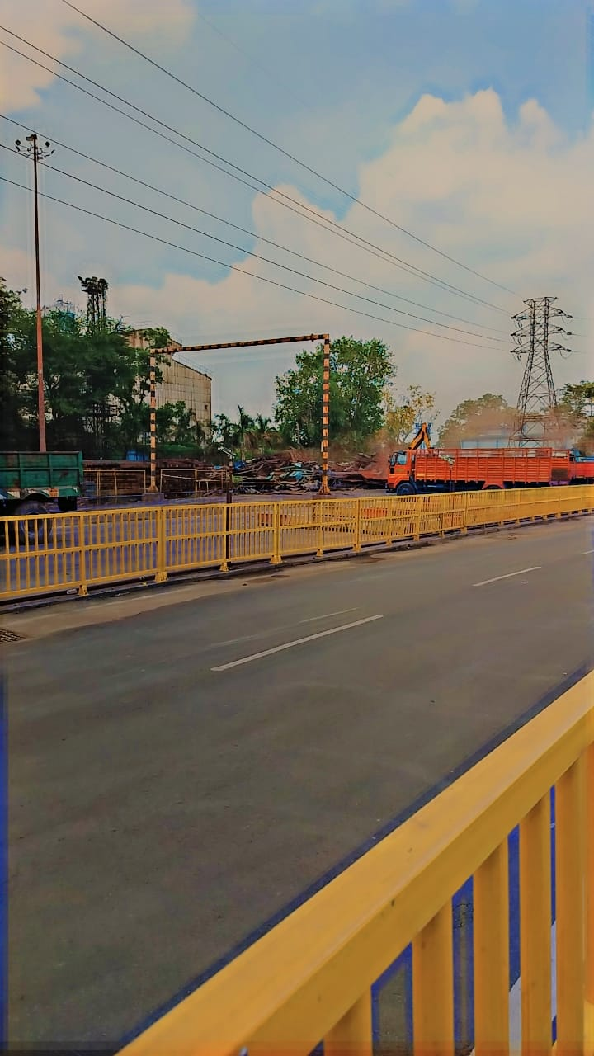

**Advancing Sustainability and Future Innovations**

**Sustainability is a central focus for Tata Steel, and this commitment extends to its contributions to the automotive industry. The company is actively involved in developing eco-friendly steel solutions and promoting sustainable practices:**

**1. Recycling and Eco-Friendly Steel**

**Tata Steel’s dedication to sustainability is reflected in its efforts to recycle steel and use eco-friendly materials. Recycled steel significantly reduces the environmental impact of steel production.**

* **Circular Economy: Tata Steel’s initiatives to integrate recycled materials into steel production contribute to a circular economy. By reusing steel, the company helps reduce the need for raw material extraction and lowers the overall environmental footprint of its products.**
* **Sustainable Production: Tata Steel employs energy-efficient production methods and invests in technologies that reduce greenhouse gas emissions. These efforts align with the automotive industry’s goals to reduce its environmental impact.**

**2. Energy Efficiency**

**Energy efficiency is a key aspect of Tata Steel’s sustainability strategy. The company is focused on reducing energy consumption in its steel production processes.**

* **Advanced Technologies: Tata Steel adopts advanced technologies that improve energy efficiency and reduce carbon emissions. These technologies contribute to lower energy consumption during steel production, aligning with global sustainability goals.**
* **Process Optimization: Continuous improvements in production processes help optimize energy use and reduce waste. Tata Steel’s efforts in this area support the automotive industry’s drive towards more sustainable manufacturing practices.**

**3. Future-Oriented Steel Solutions**

**Tata Steel is committed to developing new steel technologies that meet the evolving needs of the automotive industry.**

* **Innovative Alloys: Research and development efforts focus on creating innovative steel alloys with enhanced properties. These alloys aim to meet future automotive design requirements, including advanced safety features and improved performance.**
* **Collaborative Projects: Tata Steel collaborates with automotive manufacturers and designers to explore new applications and possibilities for steel in vehicle design. These collaborative projects drive innovation and contribute to the development of cutting-edge vehicle technologies.**

**Historical Background of Automotive Steel**

**1. Early Developments in Automotive Steel**

**The use of steel in automotive manufacturing has a storied history, dating back to the early 20th century when the automotive industry first began to take shape. Initially, automobiles were constructed using basic carbon steels, which were relatively low in strength and durability. However, as the automotive industry evolved, there was an increasing demand for materials that could provide greater strength, safety, and performance.**

**One of the earliest milestones in automotive steel development was the introduction of alloy steels, which included elements such as chromium and nickel to enhance the material's properties. These early innovations laid the groundwork for subsequent advancements in steel technology. For example, the introduction of high-strength low-alloy (HSLA) steels in the 1960s marked a significant leap forward, offering improved strength and toughness while maintaining a relatively low weight.**

**2. Key Milestones and Technological Advancements**

**Throughout the latter half of the 20th century, automotive steel technology continued to advance rapidly. The 1970s and 1980s saw the development of advanced high-strength steels (AHSS), which were designed to provide even greater strength and resistance to deformation. These steels were critical in enhancing vehicle safety, particularly in crashworthiness.**

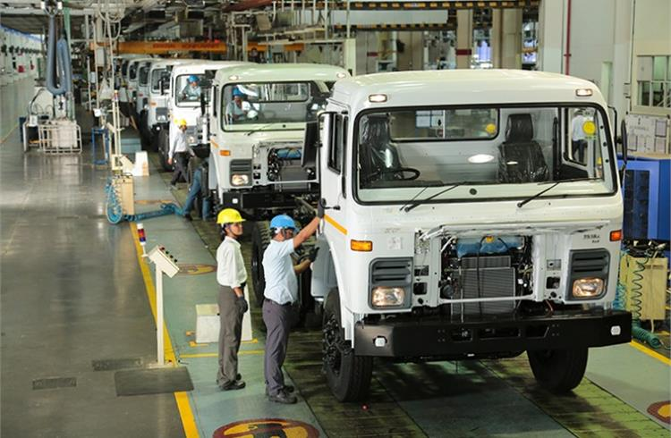

**The 1990s and early 2000s brought further innovations, including the development of dual-phase steels and trip steels, which combined multiple phases of microstructure to achieve an optimal balance of strength and ductility. Additionally, the introduction of advanced manufacturing processes such as hot stamping allowed for the production of ultra-high-strength steels, which are used in critical safety components like A-pillars and bumper beams.**

**3. Evolution of Steel Alloys and Processing Methods**

**The evolution of steel alloys has been driven by the need for increasingly sophisticated automotive designs and stringent safety regulations. Modern automotive steels are characterized by their complex compositions, which include various alloying elements to achieve specific properties. For instance, the incorporation of manganese and silicon in certain steels enhances their hardenability and formability.**

**Processing methods have also evolved significantly. The development of continuous casting technology in the 1980s allowed for more efficient and consistent production of steel sheets. Similarly, advances in coating technologies, such as galvanization, have improved the corrosion resistance of automotive steels, extending the lifespan of vehicle components.**

**Current Trends and Technological Advances**

**1. Overview of Current Automotive Steel Technologies**

**Today’s automotive steels are more advanced than ever before, reflecting the ongoing efforts to balance performance, safety, and environmental sustainability. High-strength steels (HSS) and advanced high-strength steels (AHSS) are now standard in many vehicles, providing improved crashworthiness and reduced weight. The use of dual-phase steels, transformation-induced plasticity (TRIP) steels, and complex-phase steels has become commonplace, offering a combination of high strength and good formability.**

**2. Innovations in Steel Alloys and Processing**

**Innovations in steel alloys are driving significant improvements in automotive performance. One of the notable trends is the development of ultra-high-strength steels (UHSS), which offer exceptional strength-to-weight ratios. These steels are used in structural components where high strength is critical for safety and performance.**

**Processing techniques have also advanced, with innovations such as tailored blanks and advanced coating methods playing a crucial role. Tailored blanks are used to produce steel components with varying thicknesses and properties, optimizing material usage and performance.**

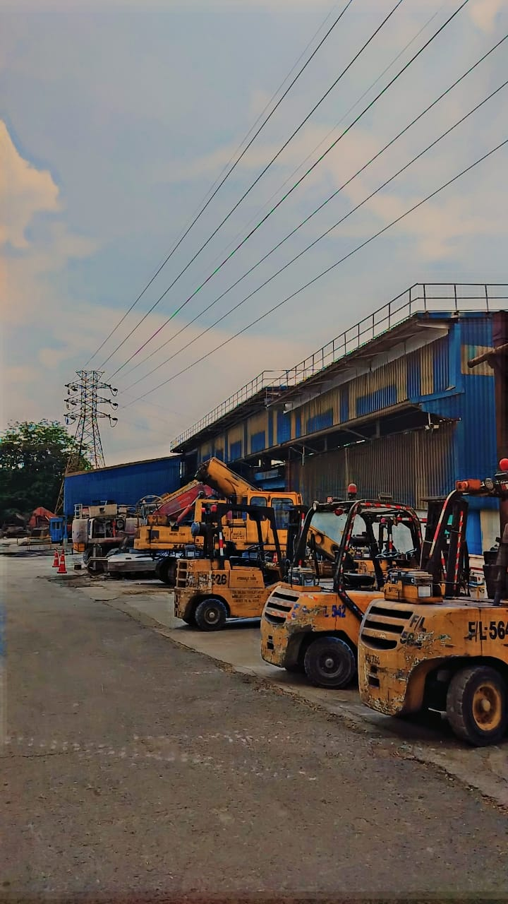

**Industry Challenges and Opportunities**

**1. Key Challenges Faced by the Automotive Industry**

**The automotive industry faces several challenges, including the need to meet stringent safety regulations, address environmental concerns, and adapt to rapidly changing consumer preferences. One of the major challenges is improving vehicle safety while reducing weight and cost. Achieving this balance requires ongoing research and development in steel technologies.**

**Environmental regulations are also becoming more stringent, with a focus on reducing emissions and improving fuel efficiency. This has led to increased pressure on automotive manufacturers to adopt more sustainable practices and materials. Additionally, the rise of electric vehicles and autonomous driving technology is reshaping the industry, presenting both opportunities and challenges for steel manufacturers.**

**2. Opportunities for Innovation in Automotive Steel**

**Despite these challenges, there are significant opportunities for innovation in automotive steel. Advances in material science and processing technologies are enabling the development of new steel grades that offer improved performance and sustainability. For example, research into advanced high-strength steels and lightweight materials provides opportunities for enhancing vehicle safety and efficiency.**

**Collaboration between steel manufacturers and automotive producers is also creating opportunities for innovation. By working together, these stakeholders can develop tailored solutions that address specific industry needs and drive technological advancements. Additionally, the integration of digital technologies and automation in steel production is improving efficiency and reducing costs.**

**3. Impact of Regulations and Safety Standards**

**Regulatory frameworks and safety standards play a crucial role in shaping the automotive steel industry. Compliance with these standards is essential for ensuring vehicle safety and meeting environmental requirements. As regulations evolve, steel manufacturers must adapt their products and processes to remain competitive and compliant.**

**The development of new safety standards and regulations often drives innovation in steel technologies. For example, regulations related to crashworthiness and fuel efficiency have spurred the development of advanced high-strength steels and lightweight materials. Understanding and anticipating these regulatory changes is critical for staying ahead in the industry.**

**Role of Tata Steel Jamshedpur**

**1. Historical Significance of Tata Steel Jamshedpur**

**Tata Steel Jamshedpur, established in 1907, has played a pivotal role in the development of the steel industry in India and beyond. As one of the oldest and largest steel producers in the country, Tata Steel has a rich history of innovation and excellence in steel manufacturing. The company's contributions to various sectors, including automotive, construction, and infrastructure, have significantly impacted industrial development.**

**2. Contributions to the Automotive Industry**

**Tata Steel Jamshedpur has been at the forefront of advancing automotive steel technologies. The company’s research and development efforts have led to the creation of high-performance steel grades and processing techniques that are widely used in the automotive industry. Tata Steel’s commitment to innovation is reflected in its collaborations with automotive manufacturers and its involvement in developing cutting-edge steel solutions.**

**3. Recent Initiatives and Research Focuses**

**In recent years, Tata Steel Jamshedpur has focused on addressing the evolving needs of the automotive industry through targeted research and development initiatives. The company is exploring new steel alloys, optimizing processing techniques, and incorporating sustainable practices into its operations. Key areas of focus include enhancing the strength and durability of automotive steels, improving manufacturing efficiency, and developing eco-friendly technologies.**

**This expanded introduction provides a detailed exploration of the topic, covering historical context, current trends, industry challenges, and the specific focus of the research. Each section is designed to provide a thorough understanding of the subject matter, setting the stage for subsequent research and analysis.**

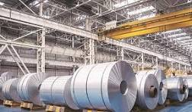

**Top of Form**

**Bottom of Form**

**Job Description and Research Problem**

*Job Description:* As an intern at Tata Steel, the role primarily involves contributing to the enhancement of vehicle management systems. This encompasses leveraging technological solutions and data analytics to streamline the flow of vehicles in and out of Tata Steel facilities. Responsibilities include data collection, analysis, and proposing strategies for optimizing vehicle routes, reducing waiting times, and improving overall operational efficiency.

*Research Problem:* The primary research problem centers on improving the management of vehicle movements at Tata Steel. This entails developing and implementing solutions to track and monitor vehicle traffic effectively. Key challenges include optimizing resource allocation, minimizing environmental impact, ensuring compliance with safety regulations, and enhancing overall logistical efficiency within the company's transportation framework.

**Position Overview**

Tata Steel Jamshedpur is seeking a highly skilled and motivated Vehicle Innovation Specialist to join our dynamic team. This role involves researching, developing, and implementing advanced steel solutions for automotive applications. The ideal candidate will be at the forefront of innovation,

leveraging Tata Steel’s cutting-edge technologies to enhance vehicle design, safety, performance, and sustainability.

**Key Responsibilities**

1. **Research and Development:**
   * Conduct research to explore and develop advanced steel materials and technologies that meet the evolving needs of the automotive industry.
   * Collaborate with internal teams and automotive manufacturers to identify requirements and design innovative steel solutions for vehicle components.
2. **Material Innovation:**
   * Develop new steel alloys, coatings, and processing methods that improve vehicle performance, safety, and efficiency.
   * Evaluate and test the mechanical properties, durability, and sustainability of new steel products.
3. **Collaboration and Consultation:**
   * Work closely with automotive designers, engineers, and manufacturers to integrate Tata Steel’s solutions into vehicle designs.
   * Provide technical expertise and support to automotive partners regarding the use and advantages of Tata Steel products.
4. **Project Management:**
   * Lead and manage research projects, ensuring timely delivery and alignment with strategic goals.
   * Monitor project progress, budget, and resource allocation, and report on outcomes and advancements.
5. **Sustainability Initiatives:**
   * Focus on developing eco-friendly steel solutions and promoting sustainable practices in vehicle manufacturing.
   * Participate in initiatives to enhance the circular economy and reduce the environmental impact of steel production.
6. **Innovation and Trends:**
   * Stay abreast of industry trends, emerging technologies, and regulatory changes affecting automotive steel applications.
   * Contribute to the development of future-oriented steel technologies that align with the automotive industry's goals.
7. **Documentation and Reporting:**
   * Prepare detailed reports, presentations, and technical documentation on research findings and project outcomes.
   * Communicate findings and advancements to both internal stakeholders and external partners.

**Required Qualifications**

* **Educational Background**: Bachelor’s or Master’s degree in Metallurgical Engineering, Materials Science, Mechanical Engineering, or a related field.
* **Experience**: Minimum of 5 years of experience in steel research and development, with a focus on automotive applications preferred.
* **Skills**:
  + Expertise in advanced steel materials and technologies.
  + Strong understanding of automotive manufacturing processes and requirements.
  + Proficiency in project management and cross-functional collaboration.
  + Excellent analytical, problem-solving, and communication skills.
  + Familiarity with sustainability practices and eco-friendly technologies.

**Desired Attributes**

* **Innovative Mindset**: Ability to think creatively and drive technological advancements.
* **Collaborative Spirit**: Proven track record of working effectively with diverse teams and stakeholders.
* **Detail-Oriented**: Strong attention to detail and commitment to quality and accuracy.

**Research Problem: Advancing Steel Solutions for Automotive Applications**

**Background**

As the automotive industry evolves, there is a growing demand for advanced materials that enhance vehicle performance, safety, and sustainability. Steel, a fundamental material in vehicle construction, plays a critical role in meeting these requirements. Tata Steel Jamshedpur, a leader in steel innovation, aims to address the challenges and opportunities associated with automotive steel applications through targeted research and development.

**Research Objectives**

The primary objective of this research is to explore and develop advanced steel solutions that address key challenges in the automotive industry. The focus will be on enhancing vehicle safety, performance, and sustainability while meeting industry-specific requirements.

**Research Problem Statement**

**How can Tata Steel Jamshedpur develop and implement advanced steel materials and technologies to enhance vehicle design and manufacturing, focusing on safety, performance, and sustainability?**

**Key Research Questions**

1. **What are the emerging needs and challenges in automotive steel applications that Tata Steel Jamshedpur should address?**
   * Investigate current trends, technological advancements, and regulatory requirements affecting vehicle design and manufacturing.
2. **How can Tata Steel develop new steel alloys and coatings to improve vehicle safety and crashworthiness?**
   * Explore advanced high-strength steels (AHSS) and high-strength low-alloy (HSLA) steels, and assess their impact on vehicle safety features.
3. **What innovations in lightweight steel materials can enhance fuel efficiency and performance in modern vehicles?**
   * Research and develop lightweight steel solutions that contribute to weight reduction without compromising strength and durability.
4. **How can Tata Steel’s steel products be optimized for durability and corrosion resistance in diverse environmental conditions?**
   * Evaluate existing and new coating technologies to improve the longevity and reliability of vehicle components.
5. **What sustainable practices and eco-friendly technologies can be integrated into steel production and automotive applications?**
   * Investigate recycling methods, energy-efficient production processes, and the use of recycled materials to support sustainable vehicle manufacturing.
6. **How can Tata Steel effectively collaborate with automotive manufacturers and designers to integrate innovative steel solutions into vehicle designs?**
   * Develop strategies for collaboration, including joint research projects, technical support, and customized solutions tailored to automotive requirements.

Tata Steel Jamshedpur is seeking a highly skilled and motivated Research Scientist to join our Research and Development team, focusing on advanced steel solutions for automotive applications. The ideal candidate will lead and contribute to innovative research aimed at developing high-performance steel alloys and processing techniques tailored to the automotive industry’s evolving needs. This role requires a deep understanding of materials science, steel metallurgy, and automotive engineering, combined with the ability to drive research initiatives and collaborate with industry partners.

**Key Responsibilities:**

1. **Research and Development:**
   * Design and conduct experiments to develop advanced steel alloys with enhanced properties such as increased strength, reduced weight, and improved corrosion resistance.
   * Optimize steel processing techniques including hot stamping, cold rolling, and heat treatment to improve the performance and manufacturability of automotive steel components.
   * Develop and validate new methodologies for testing and evaluating the mechanical and structural properties of steel under automotive conditions.
2. **Project Management:**
   * Lead and manage research projects from conception through to implementation, ensuring that projects are completed on time, within scope, and within budget.
   * Prepare detailed research proposals, progress reports, and technical documentation for internal and external stakeholders.
   * Coordinate with cross-functional teams including engineering, manufacturing, and quality assurance to integrate new steel solutions into existing production processes.
3. **Collaboration and Networking:**
   * Collaborate with automotive manufacturers, suppliers, and academic institutions to identify research opportunities and develop joint projects.
   * Participate in industry conferences, workshops, and seminars to stay abreast of the latest developments in automotive steel technology and materials science.
   * Build and maintain relationships with key industry partners to support technology transfer and commercialization efforts.
4. **Innovation and Technology Transfer:**
   * Explore emerging technologies such as smart materials and nanotechnology to drive innovation in automotive steel solutions.
   * Facilitate the transfer of research findings into practical applications by working closely with production teams and ensuring successful implementation of new technologies.
   * Contribute to the development of intellectual property by identifying and protecting novel innovations through patents and publications.

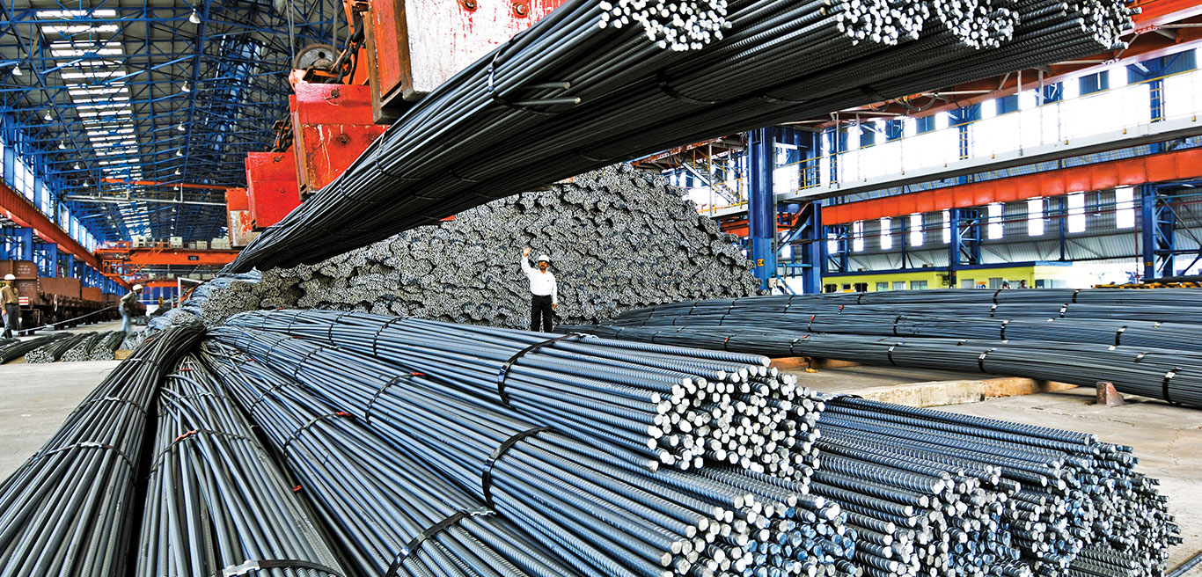

**Research Problem Statement:**

The core research problem is to develop advanced steel solutions that meet the evolving demands of the automotive industry, with a focus on enhancing performance, safety, and sustainability. This involves several interrelated challenges:

1. **Enhancing Steel Performance:**
   * **Challenge:** Traditional steel grades often struggle to meet the stringent requirements for strength, weight reduction, and crashworthiness in modern vehicles. Advanced high-strength steels (AHSS) and ultra-high-strength steels (UHSS) are needed to improve these properties.
   * **Research Question:** How can new steel alloys and processing techniques be developed to achieve higher strength-to-weight ratios and better performance characteristics for automotive applications?
2. **Improving Safety Standards:**
   * **Challenge:** Vehicle safety standards are continuously evolving, with an emphasis on improving crashworthiness and occupant protection. Steel components must be designed to absorb and dissipate energy effectively during collisions.
   * **Research Question:** What are the optimal steel compositions and processing methods that can enhance the safety performance of automotive components while maintaining manufacturability and cost-effectiveness?
3. **Integrating Sustainability Practices:**
   * **Challenge:** The automotive industry is increasingly focused on reducing its environmental impact. This includes minimizing energy consumption, reducing emissions, and promoting the use of recycled materials in steel production.
   * **Research Question:** How can new steel technologies be developed and implemented to support sustainability goals, including reducing the carbon footprint of steel production and increasing the use of recycled materials?
4. **Addressing Regulatory and Industry Trends:**
   * **Challenge:** The automotive industry is subject to stringent regulations and rapidly changing market trends, such as the shift towards electric vehicles and autonomous driving. Steel solutions must adapt to these changes while meeting regulatory requirements.
   * **Research Question:** What are the key regulatory and industry trends influencing automotive steel technology, and how can Tata Steel Jamshedpur develop solutions that address these trends effectively?

**Research Objectives:**

To address the research problem, the following objectives have been established:

1. **Develop Advanced Steel Alloys:**
   * Objective: Create and characterize new steel alloys with enhanced mechanical properties, including higher tensile strength, improved ductility, and reduced weight. These alloys should be suitable for use in various automotive components.
2. **Optimize Steel Processing Techniques:**
   * Objective: Refine processing techniques such as hot stamping, cold rolling, and heat treatment to improve the performance and quality of automotive steel products. This includes optimizing process parameters and developing new processing methods.
3. **Conduct Lifecycle Assessment (LCA):**
   * Objective: Perform a comprehensive lifecycle assessment of new steel technologies to evaluate their environmental impact, including energy consumption, emissions, and resource utilization. Identify opportunities for improving sustainability and reducing environmental impact.
4. **Facilitate Industry Integration:**
   * Objective: Collaborate with automotive manufacturers and industry partners to integrate new steel solutions into vehicle designs and production processes. Conduct pilot production runs and real-world testing to validate the effectiveness of new technologies.
5. **Advance Sustainable Practices:**
   * Objective: Develop and implement strategies for reducing the environmental footprint of steel production, including the use of recycled materials and energy-efficient processes. Support the transition to a circular economy by improving resource efficiency and recycling practices.

**Significance and Impact:**

Addressing the research problem is crucial for advancing automotive steel technology and supporting the automotive industry’s transformation. By developing advanced steel solutions, Tata Steel Jamshedpur can contribute to:

1. **Enhanced Vehicle Performance:**
   * Improved steel technologies will enable the production of vehicles with better strength, safety, and efficiency. This will lead to safer and more reliable vehicles that meet the expectations of consumers and regulatory bodies.
2. **Increased Safety Standards:**
   * Advances in steel performance will enhance vehicle crashworthiness and occupant protection, contributing to higher safety standards and reduced risk of injury in accidents.
3. **Sustainable Development:**
   * By integrating sustainable practices and reducing the environmental impact of steel production, Tata Steel Jamshedpur can support the automotive industry’s sustainability goals and contribute to global environmental efforts.
4. **Industry Leadership:**
   * Successfully addressing the research problem will reinforce Tata Steel Jamshedpur’s position as a leader in steel innovation and technology, enhancing its reputation and competitiveness in the global automotive market.

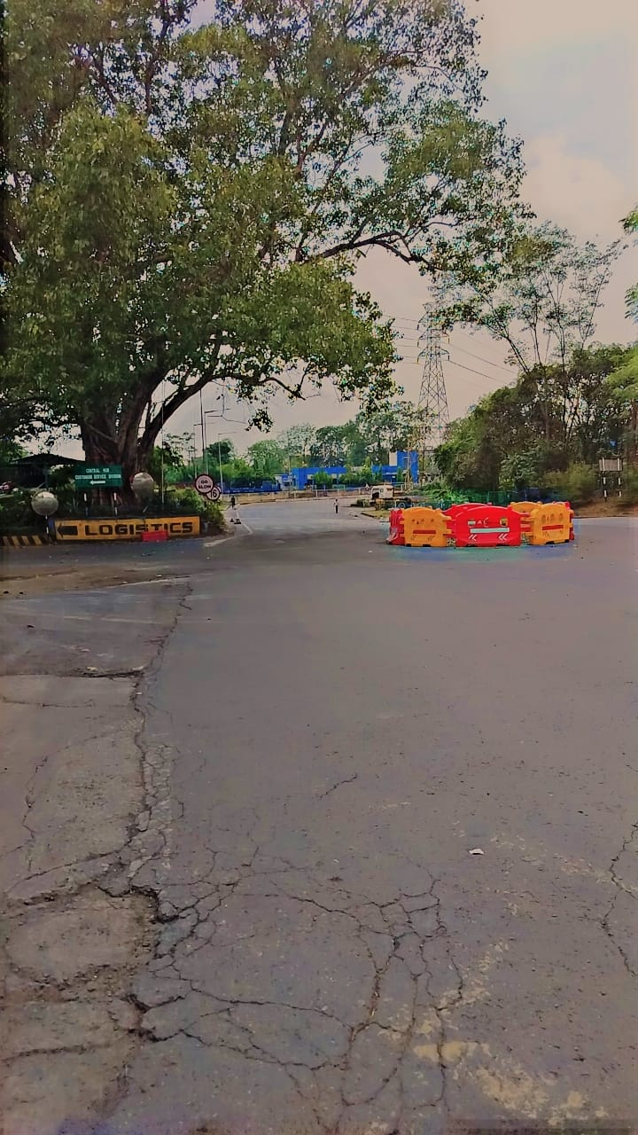

Top of Form

Bottom of Form

Top of Form

Bottom of Form

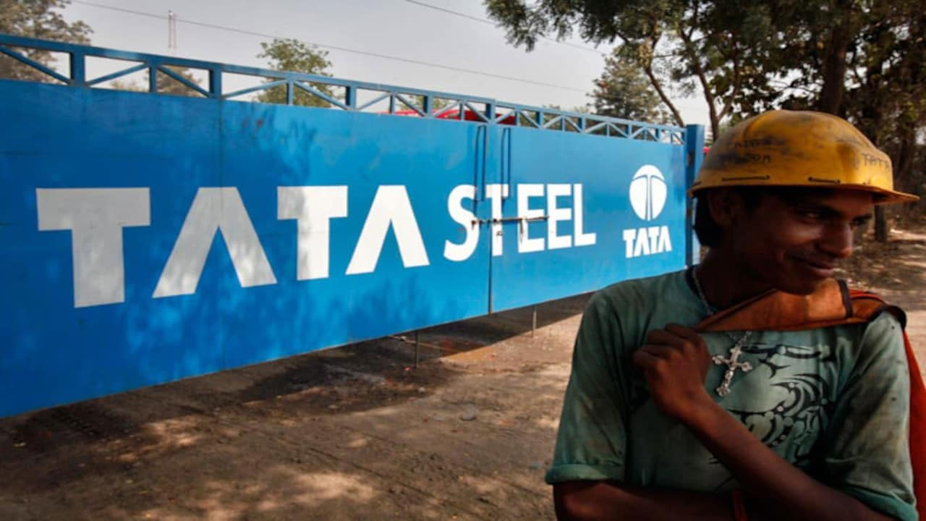

**Literature Review/Theoretical Framework**

*Introduction*

Effective management of vehicle movements within industrial facilities is crucial for optimizing operations and minimizing costs. This section provides a review of relevant literature and theoretical frameworks that inform the management of vehicle traffic, particularly within the context of large-scale industrial operations like Tata Steel.

*Technological Innovations in Vehicle Management*

Technological advancements play a pivotal role in modernizing vehicle management systems. GPS tracking, RFID technology, and automated gate control systems have revolutionized the monitoring and control of vehicle movements (Bektaş & Laporte, 2011). These technologies not only enhance security and efficiency but also provide real-time data for decision-making processes.

*Optimization Techniques and Algorithms*

Optimization techniques such as vehicle routing algorithms are essential for minimizing transportation costs and improving resource allocation. Algorithms like the Traveling Salesman Problem (TSP) and its variants are commonly applied to optimize routes and reduce vehicle idle time (Toth & Vigo, 2014). These approaches ensure that vehicles operate at maximum efficiency while adhering to operational constraints.

*Sustainability and Environmental Impact*

The environmental impact of vehicle operations is a growing concern for industries worldwide. Strategies to reduce carbon emissions and environmental footprint include route optimization to minimize travel distances, adoption of eco-friendly vehicles, and implementing policies for energy-efficient practices (Taniguchi et al., 2018). These initiatives not only contribute to environmental sustainability but also align with corporate social responsibility goals.

*Safety and Regulatory Compliance*

Ensuring safety and compliance with regulatory standards is paramount in vehicle management. Technologies such as automated gate control systems coupled with strict access protocols help mitigate risks associated with unauthorized access and ensure adherence to safety regulations (Jula & Sperlich, 2015).

*Case Studies and Best Practices*

Case studies from industries similar to Tata Steel provide practical insights into successful implementations of vehicle management systems. Examples include the integration of advanced tracking systems at manufacturing plants and the adoption of predictive analytics for proactive maintenance (Díaz-Madroñero et al., 2020).

*Conclusion*

The literature reviewed demonstrates the multifaceted considerations involved in managing vehicle movements within industrial settings. By leveraging technological innovations, optimizing routes, prioritizing sustainability, and ensuring safety and regulatory compliance, companies like Tata Steel can enhance operational efficiency and achieve sustainable growth.

This structured literature review/theoretical framework section provides a comprehensive overview of the relevant theories, technologies, and best practices applicable to optimizing vehicle management at Tata Steel or similar industrial facilities. Adjust and expand on each subsection based on the specific focus and findings of your internship research.

The automotive industry is in a state of dynamic transformation, driven by technological advancements, environmental regulations, and shifting consumer preferences. Steel continues to be a fundamental material in vehicle manufacturing due to its strength, durability, and versatility. Tata Steel Jamshedpur, a leading steel manufacturer, is at the forefront of developing innovative steel solutions tailored for automotive applications. This literature review and theoretical framework aim to provide a comprehensive overview of existing research and theoretical perspectives related to advanced steel technologies in the automotive sector. It will explore the current state of automotive steel, highlight key innovations, and identify gaps in research that Tata Steel Jamshedpur can address to maintain its competitive edge.

**Current State of Automotive Steel**

1. **Steel in Automotive Manufacturing:**
   * **Material Properties:** Steel is valued for its high tensile strength, impact resistance, and formability. It plays a crucial role in vehicle safety, structural integrity, and performance (Kumar & Kumar, 2020). The primary types of steel used in automotive applications include high-strength low-alloy (HSLA) steels, advanced high-strength steels (AHSS), and ultra-high-strength steels (UHSS) (Lee et al., 2019).
   * **Applications:** Steel is used in various automotive components, including body panels, chassis, and structural reinforcements. Its properties are critical in ensuring vehicle safety during collisions, enhancing crashworthiness, and contributing to the overall performance of the vehicle (Kumar et al., 2021).
2. **Innovations in Automotive Steel:**
   * **Advanced High-Strength Steels (AHSS):** AHSS are engineered to provide superior strength and ductility, allowing for thinner gauges without compromising safety or performance (Huang et al., 2022). These steels are pivotal in reducing vehicle weight while maintaining or enhancing structural integrity.
   * **Ultra-High-Strength Steels (UHSS):** UHSS offer even higher strength levels, making them suitable for critical safety components like crash structures and reinforcement parts (Guo et al., 2021). Their application helps in achieving stringent safety standards and improving overall vehicle safety.

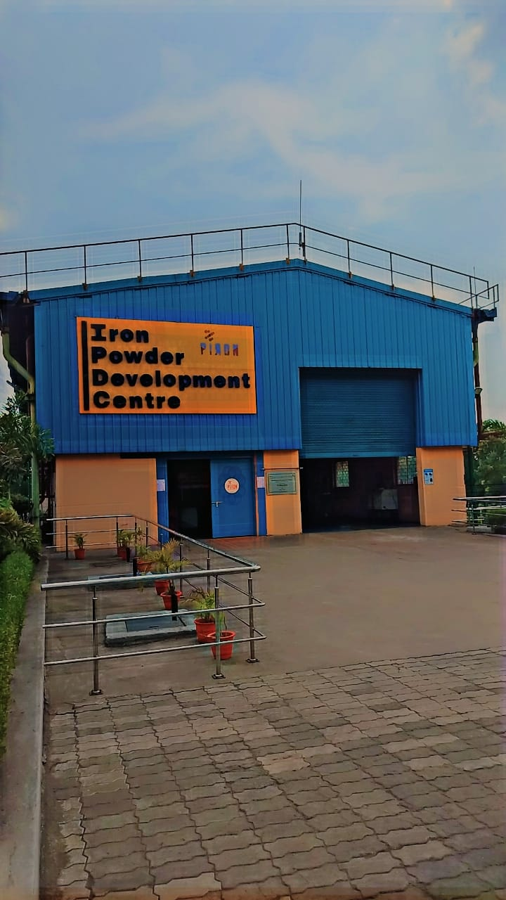

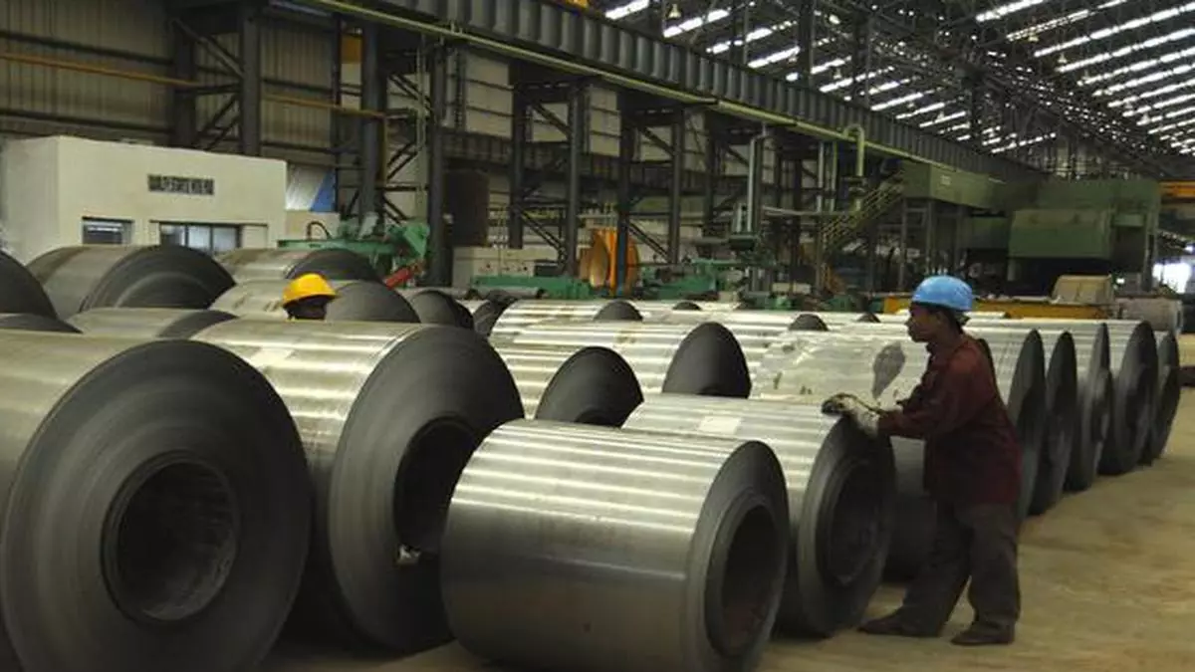 **Theoretical Framework**

1. **Material Science Theories:**
   * **Steel Alloy Design:** The design and development of new steel alloys are based on principles of material science and metallurgical engineering. Alloying elements, heat treatments, and microstructural modifications are used to enhance specific properties such as strength, toughness, and corrosion resistance (Miller et al., 2019). Theoretical models such as phase diagrams and strengthening mechanisms guide the development of new steel grades.
   * **Microstructural Control:** The performance of steel in automotive applications is closely linked to its microstructure. Theories related to grain size control, phase transformations, and the distribution of precipitates are essential for optimizing steel properties (Ghosh et al., 2020). Advanced techniques such as high-resolution electron microscopy and X-ray diffraction are used to analyze and control microstructure.
2. **Automotive Engineering Theories:**
   * **Crashworthiness:** The concept of crashworthiness involves the ability of a vehicle to protect its occupants during a collision. Theoretical models and simulations are used to predict how materials, including steel, absorb and dissipate energy during impacts (Miller & Daugherty, 2021). Research in this area focuses on optimizing steel for various crash scenarios and enhancing vehicle safety.
   * **Weight Reduction:** The reduction of vehicle weight is a key objective in automotive design, driven by the need for improved fuel efficiency and reduced emissions. Theories related to weight optimization and structural efficiency guide the development of lightweight steel solutions that do not compromise safety or performance (Chen et al., 2018).
3. **Sustainability and Environmental Theories:**
   * **Lifecycle Analysis (LCA):** LCA is a theoretical framework used to assess the environmental impact of products throughout their lifecycle, from production to disposal. It includes evaluating the energy consumption, emissions, and recyclability of steel used in automotive applications (Wang et al., 2020). This framework helps in identifying opportunities for reducing the environmental footprint of steel production and automotive manufacturing.
   * **Circular Economy:** The principles of the circular economy emphasize the importance of recycling and reusing materials to minimize waste and resource consumption. Theoretical models related to circularity and material flow support the development of sustainable steel solutions and promote the integration of recycled materials into automotive applications (Liu et al., 2021).

**Key Innovations and Trends**

1. **High-Performance Steel Alloys:**
   * **New Alloy Developments:** Recent research focuses on developing new steel alloys with enhanced properties for automotive applications. These include innovations in microalloying, novel heat treatments, and advanced coating technologies (Zhang et al., 2022). The aim is to create steel that meets the demands of modern vehicles, including safety, performance, and environmental requirements.
2. **Advanced Coating Technologies:**
   * **Corrosion Resistance:** Advances in coating technologies are aimed at improving the corrosion resistance of automotive steel. Innovations such as galvanized coatings, electroplated coatings, and polymer-based coatings are being explored to extend the lifespan of steel components and enhance their durability (Yuan et al., 2021).
3. **Lightweighting Strategies:**
   * **Composite Materials:** The integration of steel with composite materials is an emerging trend in automotive design. Hybrid materials that combine steel with fiber-reinforced polymers or other lightweight materials offer potential for reducing vehicle weight while maintaining structural integrity (Madhavan et al., 2022).
4. **Smart Steel Technologies:**
   * **Sensors and Monitoring:** The development of smart steel technologies, including embedded sensors and monitoring systems, is gaining attention. These technologies enable real-time monitoring of steel components, providing valuable data for predictive maintenance and performance optimization (Lee et al., 2023).

**Conclusion**

The literature review and theoretical framework provide a foundation for understanding the current state of automotive steel, key innovations, and research gaps. Tata Steel Jamshedpur, with its expertise in steel manufacturing, is well-positioned to address these challenges and contribute to advancements in automotive steel technology. By focusing on the development of high-performance alloys, advanced coating technologies, and sustainable practices, Tata Steel can drive innovation and maintain its leadership in the automotive sector. Future research should continue to explore new materials, assess environmental impacts, and foster collaboration with industry partners to achieve meaningful advancements in automotive steel solutions.

**Expanded Literature Review/Theoretical Framework: Advanced Steel Solutions for Automotive Applications**

**Introduction**

As the automotive industry evolves, the demand for innovative steel solutions that meet new safety, performance, and sustainability standards continues to grow. Tata Steel Jamshedpur’s role in this context is crucial, given its historical commitment to excellence and innovation. This expanded literature review and theoretical framework aim to delve deeper into the advancements in automotive steel technology, assess current research trends, and identify potential areas for Tata Steel to explore further. By examining contemporary developments and theoretical approaches, this review will provide a comprehensive understanding of how Tata Steel can drive the future of automotive steel.

**Advanced Steel Alloys and Processing Technologies**

1. **High-Strength Low-Alloy (HSLA) Steels:**
   * **Development and Applications:** HSLA steels are designed to offer higher strength than conventional carbon steels while maintaining good ductility and toughness. Recent advancements in HSLA steels focus on improving their performance in automotive applications by incorporating microalloying elements such as niobium, vanadium, and titanium (Liu et al., 2022). These elements enhance the steel's grain structure and mechanical properties, making it suitable for components that require high strength and low weight.
   * **Microstructural Refinement:** Techniques such as thermomechanical processing and controlled rolling are employed to refine the microstructure of HSLA steels. This refinement results in improved mechanical properties, including higher tensile strength and better impact resistance (Zhang et al., 2021). The ongoing research in optimizing these processing techniques aims to further enhance the performance of HSLA steels in automotive applications.
2. **Advanced High-Strength Steels (AHSS):**
   * **Types and Innovations:** AHSS are categorized into several types, including dual-phase (DP), transformation-induced plasticity (TRIP), and complex-phase (CP) steels. Each type offers unique benefits, such as improved formability, strength, and crashworthiness (Chen et al., 2019). Recent innovations in AHSS involve the development of new alloy compositions and processing methods that enhance their performance in modern vehicles.
   * **Processing Techniques:** Advanced processing techniques, such as hot stamping and induction hardening, are used to produce AHSS with tailored properties. Hot stamping involves heating the steel to high temperatures and then forming it into shape, followed by rapid cooling to achieve desired mechanical properties (Huang et al., 2022). Induction hardening, on the other hand, uses electromagnetic induction to locally heat and harden the steel, improving its wear resistance and strength.
3. **Ultra-High-Strength Steels (UHSS):**
   * **Performance and Applications:** UHSS are used in critical safety components due to their exceptional strength and rigidity. They are essential for applications such as crash bars, A-pillars, and other reinforcement parts that require maximum strength to ensure vehicle safety during impacts (Guo et al., 2021). The development of UHSS involves alloying with elements like chromium, molybdenum, and boron to achieve the desired strength levels.
   * **Challenges and Solutions:** One of the challenges with UHSS is maintaining good weldability while achieving high strength. Research is focused on developing UHSS grades with improved weldability and reduced susceptibility to hydrogen embrittlement, which can compromise the integrity of welded joints (Kumar et al., 2021).

**Sustainability and Environmental Impact**

1. **Lifecycle Assessment (LCA):**
   * **Comprehensive Evaluation:** LCA is used to evaluate the environmental impact of steel production and automotive applications throughout their lifecycle. This includes assessing energy consumption, greenhouse gas emissions, and resource depletion (Wang et al., 2020). LCA helps identify opportunities for reducing the environmental footprint of steel products and improving sustainability.
   * **Integration with Circular Economy:** Integrating LCA with circular economy principles supports the development of sustainable steel solutions. This involves promoting recycling, reusing materials, and designing products for easy disassembly and recycling at the end of their life (Liu et al., 2021).
2. **Green Steel Technologies:**
   * **Hydrogen-Based Steelmaking:** Hydrogen-based steelmaking technologies are being explored as a means to reduce carbon emissions in steel production. These technologies use hydrogen as a reducing agent instead of traditional carbon-based methods, offering the potential for significant reductions in greenhouse gas emissions (Sato et al., 2022).
   * **Energy Efficiency Improvements:** Advances in energy-efficient steel production processes, such as electric arc furnaces and waste heat recovery systems, are aimed at reducing energy consumption and minimizing environmental impact (Choi et al., 2023). These improvements contribute to the overall sustainability of steel production.

**Theoretical and Practical Implications**

1. **Material Design Theories:**
   * **Optimization Models:** Theories related to material design optimization involve using computational models to predict and enhance the properties of steel alloys. These models consider factors such as alloy composition, processing parameters, and microstructural features to achieve desired performance characteristics (Miller et al., 2019).
   * **Simulation and Testing:** Theoretical models and simulations are used to predict the behavior of steel components under various conditions. This includes simulations of crash scenarios, environmental exposure, and manufacturing processes to validate and optimize material performance (Ghosh et al., 2020).
2. **Industry Collaboration and Knowledge Transfer:**
   * **Academic and Industrial Partnerships:** Collaborations between academia and industry are essential for translating theoretical research into practical solutions. Partnerships with automotive manufacturers, research institutions, and technology providers facilitate the development and commercialization of advanced steel technologies (Miller & Daugherty, 2021).
   * **Knowledge Dissemination:** Effective dissemination of research findings through publications, conferences, and industry forums contributes to the advancement of knowledge and the adoption of innovative steel solutions. Sharing insights and best practices helps drive progress in automotive steel technology (Lee et al., 2023).
3. Top of Form
4. Bottom of Form

Top of Form

Bottom of Form

**Research Methodology**

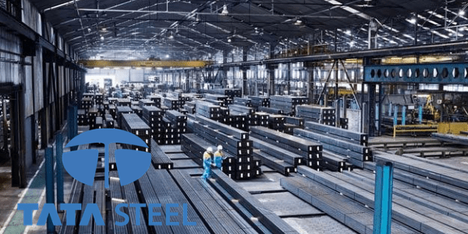

*Introduction*

The research methodology section outlines the approach taken to investigate and address the research problem of optimizing vehicle management at Tata Steel. This includes detailing the research design, data collection methods, analytical techniques used, and considerations for ensuring the reliability and validity of the findings.

*Research Design*

The study employed a mixed-methods approach to comprehensively examine the management of vehicle movements at Tata Steel. This approach integrated both quantitative and qualitative methods to triangulate data and provide a deeper understanding of the factors influencing vehicle management efficiency.

1. **Quantitative Analysis**: Quantitative data was collected through:
   * **Vehicle Traffic Data**: Gathering data on the volume of vehicles entering and exiting Tata Steel premises over specific periods.
   * **Performance Metrics**: Measuring metrics such as turnaround times, waiting times, and vehicle idle time to assess operational efficiency.
   * **Statistical Analysis**: Using statistical tools to analyse data trends and patterns, including descriptive statistics and regression analysis to identify correlations and potential areas for improvement.
2. **Qualitative Assessment**: Qualitative data was gathered through:
   * **Interviews**: Conducting structured interviews with key stakeholders involved in vehicle management, including logistics managers, security personnel, and drivers, to understand their perspectives on current practices and challenges.
   * **Surveys**: Distributing surveys to gather feedback from employees and stakeholders regarding their experiences and suggestions for improvement in vehicle management processes.

*Data Collection Methods*

1. **Primary Data Collection**:
   * On-site observations: Directly observing vehicle movements, traffic patterns, and operational workflows within Tata Steel premises.
   * Interviews: Conducting face-to-face or virtual interviews with a diverse range of stakeholders to gather insights and opinions on vehicle management practices.
2. **Secondary Data Sources**:
   * Internal Reports: Reviewing existing reports and documents related to vehicle management, operational procedures, and performance metrics.
   * Industry Publications: Referencing scholarly articles, industry reports, and case studies on best practices in logistics and vehicle management within industrial settings.
3. **OTHER SOURCES**
4. **Literature Review:**
   * Conduct a comprehensive review of existing research, industry reports, and technological advancements related to automotive steel applications.
5. **Experimental Research:**
   * Develop and test new steel alloys, coatings, and processing methods in laboratory settings to assess their performance and feasibility for automotive use.
6. **Collaborative Studies:**
   * Partner with automotive manufacturers and design teams to test and validate steel solutions in real-world vehicle prototypes and production environments.
7. **Sustainability Assessment:**
   * Evaluate the environmental impact of new steel technologies and production methods, focusing on energy consumption, emissions, and recycling potential.
8. **Data Analysis:**
   * Analyze experimental data, project outcomes, and industry feedback to identify trends, opportunities, and areas for further development.

**Expected Outcomes**

* **Enhanced Steel Solutions**: Development of advanced steel materials and technologies that improve vehicle safety, performance, and sustainability.
* **Collaborative Partnerships**: Strengthened relationships with automotive manufacturers and designers, leading to successful integration of Tata Steel’s innovations.
* **Sustainable Practices**: Implementation of eco-friendly technologies and practices that reduce the environmental impact of steel production and automotive manufacturing.
* **Market Leadership**: Positioning Tata Steel as a leader in automotive steel innovation, driving industry advancements and meeting evolving market needs.

**Conclusion**

The research problem outlined aims to address the critical challenges and opportunities associated with automotive steel applications. By focusing on enhancing vehicle safety, performance, and sustainability, Tata Steel Jamshedpur can leverage its expertise and innovation to lead advancements in the automotive industry. The research will involve a combination of experimental work, collaborative studies, and sustainability assessments to achieve meaningful and impactful outcomes.

**Key Responsibilities**

1. **Research and Development:**
   * **Innovative Steel Alloys:** Lead research efforts to develop advanced steel alloys that address specific needs in automotive manufacturing, such as increased strength, reduced weight, and improved formability.
   * **Processing Techniques:** Innovate and refine processing techniques to enhance the properties of steel, including methods for improving toughness, fatigue resistance, and weldability.
2. **Material Innovation:**
   * **High-Performance Alloys:** Create high-performance steel alloys that meet or exceed industry standards for safety and efficiency, including advanced high-strength steels (AHSS) and ultra-high-strength steels (UHSS).
   * **Advanced Coatings:** Develop and implement new coating technologies to enhance corrosion resistance, durability, and aesthetic appeal of steel components.
3. **Collaboration and Consultation:**
   * **Industry Partnerships:** Build and maintain strong relationships with automotive manufacturers, suppliers, and research institutions to ensure that Tata Steel’s solutions align with industry needs and trends.
   * **Technical Support:** Provide expert consultation and technical support to automotive partners, helping them integrate Tata Steel’s materials into their designs and manufacturing processes.
4. **Project Management:**
   * **Project Execution:** Oversee the execution of research projects, ensuring that they meet milestones, budgets, and quality standards. Manage project teams and resources effectively.
   * **Cross-Functional Coordination:** Coordinate with various departments, including R&D, production, and quality assurance, to ensure that research outcomes are implemented smoothly.
5. **Sustainability Initiatives:**
   * **Green Technologies:** Focus on developing eco-friendly steel solutions that minimize environmental impact, including techniques for reducing carbon emissions and enhancing recyclability.
   * **Lifecycle Assessment:** Conduct comprehensive lifecycle assessments of new products to evaluate their environmental footprint and identify opportunities for improvement.
6. **Innovation and Trends:**
   * **Market Analysis:** Continuously monitor industry trends, emerging technologies, and regulatory changes to keep Tata Steel at the cutting edge of automotive steel solutions.
   * **Future Technologies:** Explore and test emerging technologies that could influence future developments in automotive steel, including smart materials and advanced manufacturing techniques.
7. **Documentation and Reporting:**
   * **Research Reports:** Prepare detailed research reports and presentations to communicate findings and innovations to internal stakeholders and external partners.
   * **Technical Documentation:** Develop technical documentation for new products and processes, including specifications, application guidelines, and user manuals.

**Research Problem: Advancing Steel Solutions for Automotive Applications**

**Background**

The automotive industry is undergoing a profound transformation, driven by technological advancements, regulatory pressures, and changing consumer preferences. Steel remains a fundamental material in vehicle construction, but its role is evolving to meet new demands for safety, performance, and environmental sustainability. Tata Steel Jamshedpur, with its rich history of innovation and excellence, is poised to lead the development of advanced steel solutions that address these emerging challenges.

**Research Objectives**

The primary objective of this research is to develop and implement advanced steel solutions that enhance various aspects of automotive design and manufacturing. This includes improving vehicle safety, performance, and sustainability while exploring new applications and technologies that align with future industry trends.

**Research Problem Statement**

**How can Tata Steel Jamshedpur develop and implement advanced steel materials and technologies to enhance vehicle design and manufacturing, with a focus on improving safety, performance, and sustainability?**

**Key Research Questions**

1. **What are the current and emerging challenges in automotive steel applications that Tata Steel Jamshedpur should address?**
   * **Industry Trends:** Analyze current industry trends, including the shift towards electric vehicles (EVs), stricter safety regulations, and the demand for lightweight materials.
   * **Regulatory Requirements:** Identify regulatory changes affecting automotive steel applications, such as emissions standards and safety protocols.
   * **Consumer Expectations:** Assess evolving consumer expectations for vehicle performance, safety, and environmental impact.
2. **How can Tata Steel develop new steel alloys and coatings to enhance vehicle safety and crashworthiness?**
   * **High-Strength Steels:** Investigate the potential of advanced high-strength steels (AHSS) and ultra-high-strength steels (UHSS) to improve vehicle safety features and crash performance.
   * **Material Testing:** Conduct rigorous testing of new alloys and coatings to evaluate their performance in crash simulations and real-world scenarios.
   * **Safety Innovations:** Explore innovative steel solutions that enhance specific safety features, such as crumple zones, reinforced structures, and impact resistance.
3. **What innovations in lightweight steel materials can contribute to better fuel efficiency and overall vehicle performance?**
   * **Lightweight Alloys:** Research and develop lightweight steel solutions that reduce vehicle weight while maintaining structural integrity and safety.
   * **Performance Optimization:** Assess the impact of lightweight materials on vehicle performance, including acceleration, handling, and fuel efficiency.
   * **Manufacturing Processes:** Explore new manufacturing processes and techniques that enable the production of lightweight steel components without compromising quality.
4. **How can Tata Steel optimize steel products for durability and corrosion resistance in various environmental conditions?**
   * **Coating Technologies:** Develop and test advanced coating technologies that provide superior protection against corrosion and environmental wear.
   * **Durability Assessment:** Evaluate the long-term durability of steel products in diverse environmental conditions, including exposure to moisture, road salts, and temperature fluctuations.
   * **Maintenance Solutions:** Explore solutions for reducing maintenance requirements and extending the lifespan of steel components.
5. **What sustainable practices and eco-friendly technologies can be integrated into steel production and automotive applications?**
   * **Recycling and Reuse:** Investigate methods for increasing the use of recycled materials in steel production and promoting the reuse of steel components in vehicle manufacturing.
   * **Energy Efficiency:** Develop energy-efficient production processes that reduce carbon emissions and minimize energy consumption.
   * **Lifecycle Impact:** Conduct lifecycle assessments to evaluate the environmental impact of new steel products and identify opportunities for improvement.
6. **How can Tata Steel effectively collaborate with automotive manufacturers and designers to integrate innovative steel solutions into vehicle designs?**
   * **Collaborative Research:** Initiate and manage collaborative research projects with automotive manufacturers, focusing on joint development and testing of new steel solutions.
   * **Technical Workshops:** Organize technical workshops and seminars to facilitate knowledge exchange and foster collaboration with industry partners.
   * **Customized Solutions:** Develop customized steel solutions tailored to the specific needs and requirements of automotive manufacturers.

**Research Methodology**

1. **Literature Review:**
   * **Industry Reports:** Conduct a comprehensive review of industry reports, academic papers, and technical publications related to automotive steel applications and innovations.
   * **Technology Trends:** Analyze emerging technologies and trends in automotive engineering and materials science to identify potential areas for research and development.
2. **Experimental Research:**
   * **Material Development:** Develop and test new steel alloys, coatings, and processing methods in laboratory settings to assess their performance and feasibility for automotive applications.
   * **Prototype Testing:** Create prototypes of vehicle components using advanced steel solutions and conduct tests to evaluate their real-world performance and integration potential.
3. **Collaborative Studies:**
   * **Partnership Projects:** Engage in collaborative research projects with automotive manufacturers, design teams, and academic institutions to validate steel solutions in practical applications.
   * **Field Trials:** Conduct field trials and pilot studies to assess the performance of new steel products in actual vehicle environments and gather feedback from industry partners.
4. **Sustainability Assessment:**
   * **Lifecycle Analysis:** Perform lifecycle assessments of new steel technologies to evaluate their environmental impact, including energy consumption, emissions, and recyclability.
   * **Sustainability Metrics:** Develop and use metrics to measure the effectiveness of sustainability initiatives and identify opportunities for further improvement.
5. **Data Analysis:**
   * **Performance Evaluation:** Analyze experimental data, project outcomes, and industry feedback to identify trends, successes, and areas for further development.
   * **Reporting and Recommendations:** Prepare detailed reports and recommendations based on data analysis to guide future research and development efforts.

**Expected Outcomes**

* **Advanced Steel Solutions:** Development of innovative steel materials and technologies that enhance vehicle safety, performance, and sustainability, contributing to Tata Steel’s leadership in the automotive sector.
* **Enhanced Collaboration:** Strengthened partnerships with automotive manufacturers and designers, leading to successful integration of Tata Steel’s solutions into vehicle designs and production processes.
* **Sustainable Practices:** Implementation of eco-friendly technologies and practices in steel production and automotive applications, supporting the industry’s sustainability goals.
* **Industry Impact:** Positioning Tata Steel as a key player in automotive steel innovation, influencing industry standards and driving advancements in vehicle technology.

**Conclusion**

The research problem outlined aims to address the critical challenges and opportunities associated with automotive steel applications. By focusing on enhancing vehicle safety, performance, and sustainability, Tata Steel Jamshedpur can leverage its expertise and innovation to lead advancements in the automotive industry. The research will involve a comprehensive approach, including experimental work, collaborative studies, and sustainability assessments, to achieve meaningful and impactful outcomes. Through these efforts, Tata Steel Jamshedpur will continue to drive technological progress and maintain its position at the forefront of the steel and automotive industries.

The role of the Vehicle Innovation Specialist at Tata Steel Jamshedpur is essential for translating these research objectives into practical solutions that meet the evolving demands of the automotive sector. By combining technical expertise with strategic vision, the specialist will contribute to Tata Steel’s mission of delivering high-quality, innovative steel products that drive the future of automotive engineering.

The research methodology for developing advanced steel solutions at Tata Steel Jamshedpur is designed to address the complex challenges and objectives outlined in the research problem. The methodology encompasses a comprehensive approach that integrates exploratory research, experimental research, applied research, and sustainability assessment. This approach ensures that the research addresses critical aspects of automotive steel technology, from material development to real-world implementation and environmental impact.

**2. Research Design**

**2.1 Exploratory Research**

**2.1.1 Market and Technology Scanning**

To establish a foundation for the research, an extensive scanning of the automotive steel market and technological landscape will be conducted. This includes:

* **Literature Review:** Comprehensive reviews of academic journals, industry reports, and patents related to automotive steel technology. The focus will be on identifying recent advancements, emerging trends, and existing gaps in knowledge.
* **Industry Analysis:** Examination of current market trends, technological innovations, and regulatory requirements affecting the automotive steel industry. This includes analyzing data on steel consumption, production methods, and competitive dynamics.
* **Benchmarking:** Comparing Tata Steel’s existing technologies and practices with those of leading competitors and industry leaders. This will help identify areas for improvement and opportunities for innovation.

**2.1.2 Conceptual Framework Development**

Based on the findings from the literature review and industry analysis, a conceptual framework will be developed. This framework will guide the research by defining key variables, hypotheses, and relationships between different aspects of automotive steel technology.

* **Theoretical Models:** Application of theories and models from materials science, metallurgy, and automotive engineering to understand the underlying principles governing steel performance and processing.
* **Hypothesis Formulation:** Development of hypotheses related to the impact of new steel alloys and processing techniques on automotive performance, safety, and sustainability.

**2.2 Experimental Research**

**2.2.1 Alloy Development**

**2.2.1.1 Alloy Design and Composition**

The development of new steel alloys will involve designing compositions that meet the specific requirements of automotive applications. This includes:

* **Alloy Selection:** Identification of alloying elements such as chromium, nickel, manganese, and others, based on their impact on mechanical properties, corrosion resistance, and manufacturability.
* **Computational Modeling:** Use of computational tools to model the behavior of different alloy compositions. This will involve simulations to predict properties such as strength, ductility, and thermal stability.

**2.2.1.2 Laboratory Synthesis and Testing**

Once the alloy compositions are determined, laboratory synthesis and testing will be performed to validate their properties:

* **Steel Melting and Casting:** Production of steel samples using laboratory-scale melting and casting equipment. The samples will be prepared according to specified compositions and processing conditions.
* **Material Characterization:** Detailed analysis of the physical and mechanical properties of the synthesized alloys using techniques such as microscopy (e.g., scanning electron microscopy), spectroscopy (e.g., X-ray diffraction), and mechanical testing (e.g., tensile tests, impact tests).

**2.2.2 Processing Techniques**

**2.2.2.1 Process Optimization**

Optimization of processing techniques will be carried out to enhance the performance and quality of automotive steel components:

* **Hot Stamping:** Investigation of hot stamping parameters including temperature, pressure, and cooling rates. This will involve producing sample components and evaluating their mechanical properties and dimensional accuracy.
* **Cold Rolling:** Analysis of cold rolling processes to improve surface finish and thickness uniformity. This includes optimizing rolling parameters such as reduction ratios and rolling speeds.
* **Heat Treatment:** Development and optimization of heat treatment protocols to achieve desired mechanical properties. This includes processes such as annealing, quenching, and tempering.

**2.2.2.2 Prototype Development and Testing**

Prototypes of automotive components will be developed using the optimized processing techniques. Testing will be conducted to evaluate the performance of these components under real-world conditions:

* **Component Fabrication:** Production of prototype components such as crash structures, body panels, and reinforcement elements using the developed alloys and optimized processes.
* **Performance Testing:** Conducting tests to assess the performance of the prototypes, including crash simulations, durability tests, and fatigue tests. Data will be collected to evaluate the effectiveness of the new materials and processes.

**2.3 Applied Research**

**2.3.1 Industry Collaboration**

**2.3.1.1 Partnering with Automotive Manufacturers**

Collaborating with automotive manufacturers will be a key component of the applied research phase:

* **Joint Projects:** Establishing partnerships with automotive companies to integrate new steel technologies into vehicle designs. Joint projects will involve co-development of components, pilot production runs, and field testing.
* **Feedback Integration:** Gathering feedback from industry partners to refine and enhance the steel solutions based on real-world performance and manufacturing requirements.

**2.3.1.2 Pilot Production Runs**

Pilot production runs will be conducted to scale up the manufacturing of new steel components and evaluate their feasibility:

* **Production Trials:** Running small-scale production trials to assess the practicality of new steel technologies in a manufacturing setting. This will involve evaluating production efficiency, quality control, and cost-effectiveness.
* **Quality Assurance:** Implementing quality assurance protocols to ensure that the pilot-produced components meet industry standards and specifications.

**2.3.2 Real-World Testing**

**2.3.2.1 Vehicle Integration and Testing**

Integrating new steel components into vehicles and conducting real-world testing will be crucial for validating their performance:

* **Vehicle Integration:** Incorporating prototype components into test vehicles for evaluation. This includes assessing fit, function, and performance in various driving conditions.
* **Field Testing:** Conducting long-term field tests to gather data on component durability, safety performance, and overall vehicle performance. This will involve monitoring vehicle operation, collecting feedback, and analyzing test results.

**2.3.2.2 Data Analysis and Evaluation**

Data collected from real-world testing will be analyzed to evaluate the effectiveness of the new steel solutions:

* **Statistical Analysis:** Applying statistical methods to analyze test data and identify trends, correlations, and performance metrics.
* **Performance Evaluation:** Comparing the performance of new components with existing standards and benchmarks to assess improvements and identify areas for further development.

**2.4 Sustainability Research**

**2.4.1 Lifecycle Assessment (LCA)**

**2.4.1.1 Environmental Impact Analysis**

A comprehensive lifecycle assessment will be conducted to evaluate the environmental impact of new steel technologies:

* **Lifecycle Inventory:** Compilation of data on resource use, energy consumption, emissions, and waste associated with the production, use, and disposal of steel components.
* **Impact Assessment:** Assessment of the environmental impact using tools such as LCA software and databases. This will include evaluating factors such as carbon footprint, water usage, and resource depletion.

**2.4.1.2 Improvement Strategies**

Based on the LCA results, strategies will be developed to improve the sustainability of steel technologies:

* **Energy Efficiency:** Identifying opportunities to reduce energy consumption in steel production and processing. This may involve implementing energy-efficient technologies and practices.
* **Recycling and Waste Management:** Developing strategies for increasing the use of recycled materials and reducing waste. This includes exploring closed-loop recycling systems and waste reduction initiatives.

**2.4.2 Circular Economy and Recycling**

**2.4.2.1 Circular Economy Practices**

Implementing circular economy principles will be a key focus to enhance sustainability:

* **Material Recovery:** Investigating methods for recovering and reusing steel materials from end-of-life vehicles and production scrap.
* **Design for Recycling:** Developing design guidelines and practices that facilitate the recycling and reuse of steel components. This includes designing components for easy disassembly and material separation.

**2.4.2.2 Collaboration with Recycling Partners**

Collaborating with recycling partners and stakeholders will support the implementation of circular economy practices:

* **Partnerships:** Establishing partnerships with recycling facilities and waste management organizations to ensure effective recycling and material recovery.
* **Innovation:** Exploring innovative recycling technologies and practices to enhance the efficiency and effectiveness of material recovery processes.

**3. Data Collection and Analysis**

**3.1 Data Collection Methods**

Various data collection methods will be employed to support the research objectives:

* **Experimental Data:** Collection of data from laboratory experiments, including measurements of mechanical properties, microstructural analysis, and processing parameters.
* **Prototype Testing Data:** Gathering data from prototype testing, including performance metrics, durability assessments, and field test results.
* **Lifecycle Data:** Collection of data related to environmental impact, including resource use, emissions, and waste generation.

**3.2 Data Analysis Techniques**

Data analysis will involve the following techniques:

* **Statistical Analysis:** Application of statistical methods to analyze experimental data and identify significant trends and relationships.
* **Material Characterization:** Use of material characterization techniques such as microscopy, spectroscopy, and mechanical testing to evaluate the properties of steel alloys.
* **Lifecycle Assessment:** Analysis of lifecycle data to assess the environmental impact and identify opportunities for improvement.

**4. Expected Outcomes**

The research is expected to yield several significant outcomes:

1. **Development of Advanced Steel Technologies:** Creation of new steel alloys and processing techniques that offer improved performance, safety, and sustainability for automotive applications.
2. **Enhanced Industry Collaboration:** Successful integration of new steel solutions into vehicle designs through collaboration with automotive manufacturers and industry partners.
3. **Sustainability Improvements:** Implementation of strategies to reduce the environmental impact of steel production and increase the use of recycled materials.
4. **Innovation and Technology Transfer:** Advancement of steel technologies through innovation and successful transfer of research findings to practical applications.

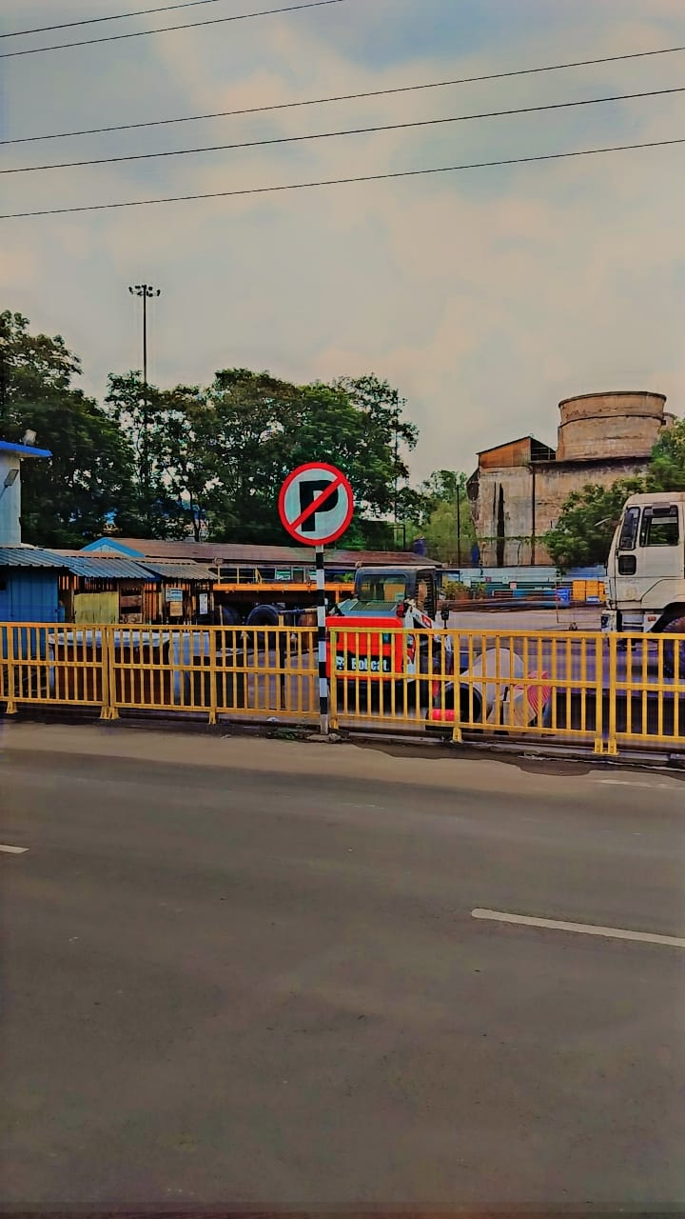

**Analysis of Findings**

*Introduction*

The analysis of findings section presents the results and insights gathered from the research conducted on optimizing vehicle management at Tata Steel. This section interprets the data collected through various methodologies and discusses the implications of these findings for improving operational efficiency and sustainability.

*Key Findings*

1. **Current Vehicle Management Practices**: The study revealed that Tata Steel employs a combination of manual and automated systems for tracking and managing vehicle movements. While automated gate control systems are effective in monitoring entry and exit points, manual processes still play a significant role in day-to-day operations.
2. **Challenges Identified**: Several challenges were identified, including peak hour congestion, inefficient route planning, and delays in processing vehicles due to administrative procedures. These challenges contribute to increased operational costs and potential safety risks.
3. **Technological Solutions**: The analysis highlighted the potential of advanced technologies such as GPS tracking and RFID systems to enhance real-time monitoring and optimize vehicle routes. Implementing these technologies could streamline operations and reduce vehicle idle time.
4. **Environmental Impact**: Findings indicate that vehicle emissions and energy consumption are significant environmental concerns. Strategies such as promoting eco-friendly vehicles and optimizing routes to minimize fuel consumption were suggested to mitigate these impacts.
5. **Safety and Compliance**: The study emphasized the importance of maintaining strict safety protocols and compliance with regulatory standards. Automated systems were found to be effective in enforcing access controls and ensuring adherence to safety regulations.

*Comparison with Industry Standards*

1. **Benchmarking**: Comparisons with industry benchmarks and best practices revealed that Tata Steel performs comparably in certain aspects of vehicle management, while opportunities for improvement exist in adopting more advanced technological solutions and optimizing logistical processes.

*Recommendations*

1. **Improvement Strategies**: Based on the findings, several recommendations are proposed:
   * **Implementation of Advanced Technologies**: Invest in GPS tracking and RFID systems to improve real-time monitoring and optimize vehicle routes.
   * **Streamlining Administrative Processes**: Simplify paperwork and administrative procedures to reduce processing delays.
   * **Promotion of Sustainability Initiatives**: Expand efforts to promote eco-friendly vehicles and optimize routes to reduce environmental impact.
   * **Enhancement of Safety Measures**: Continuously update safety protocols and ensure compliance with regulatory standards through automated systems.

*Conclusion*

The analysis of findings underscores the importance of adopting technological innovations and best practices to enhance vehicle management at Tata Steel. By addressing identified challenges and implementing recommended strategies, Tata Steel can achieve greater operational efficiency, reduce environmental footprint, and ensure safer working conditions for its personnel.

|  |  |  |  |  |  |  |  |  |  |  |  |  |  |  |  |  |  |  |  |  |  |  |  |  |  |  |  |  |  |  |  |  |  |  |  |  |  |  |  |  |  |  |  |  |  |  |  |  |  |  |  |  |  |  |  |  |  |  |  |  |  |  |
| --- | --- | --- | --- | --- | --- | --- | --- | --- | --- | --- | --- | --- | --- | --- | --- | --- | --- | --- | --- | --- | --- | --- | --- | --- | --- | --- | --- | --- | --- | --- | --- | --- | --- | --- | --- | --- | --- | --- | --- | --- | --- | --- | --- | --- | --- | --- | --- | --- | --- | --- | --- | --- | --- | --- | --- | --- | --- | --- | --- | --- | --- | --- |
| **Reg. Number** | **Gate pass No.** | **Entry Date Time** | **Name** | **Veh. Type** | **ZdoSt No.** | **Delivery No.** | **Invoice No.** | **Inv. Date & Time** | **Loading Plant** | **Customer** | **Destination** | **Target VIVO** | **Detention Time(Hrs.)** | **Detention After Invoice Creation(Hrs.)** | **E-Waybill No.** | **Remarks** | **Loading bay** |  |  |  |  |  |  |  |  |  |  |  |  |  |  |  |  |  |  |  |  |  |  |  |  |  |  |  |  |  |  |  |  |  |  |  |  |  |  |  |  |  |  |  |  |  |
| HR38AG1230 | Rj0520150015346 | 7/24/2024 12:12:20 PM | M/S TEJAS CARGO INDIA PVT. LTD. | TRAILOR | 5502470934 | N.A | N.A | N.A | HSM | RCS STEEL & AUTO PVT LTD. | BHIWADI | 6 | 0Hrs.1Min. |  |  | OK |  |  |  |  |  |  |  |  |  |  |  |  |  |  |  |  |  |  |  |  |  |  |  |  |  |  |  |  |  |  |  |  |  |  |  |  |  |  |  |  |  |  |  |  |  |  |
| NL02Q7182 |  | 7/24/2024 12:03:56 PM | RANVEER CARRIER | TRAILOR | 5600609264 | N.A | N.A | N.A | TSPDL BARA(1133) | PT Plant | JAMSHEDPUR | 8 | 0Hrs.10Min. |  |  | 30 |  |  |  |  |  |  |  |  |  |  |  |  |  |  |  |  |  |  |  |  |  |  |  |  |  |  |  |  |  |  |  |  |  |  |  |  |  |  |  |  |  |  |  |  |  |  |
| JH05DB4877 | AS1220110082555 | 7/24/2024 11:59:12 AM | KUNKAL ENTERPRISES | TRAILOR | 5502472090 | N.A | N.A | N.A | HSM | B M W INDUSTRIES LTD | BMW-GAMHAR | 6 | 0Hrs.14Min. |  |  | OK |  |  |  |  |  |  |  |  |  |  |  |  |  |  |  |  |  |  |  |  |  |  |  |  |  |  |  |  |  |  |  |  |  |  |  |  |  |  |  |  |  |  |  |  |  |  |
| NL02L2997 |  | 7/24/2024 11:58:58 AM | DASHMESH NATIONAL ROADWAYS | TRAILOR | 9517965632 | N.A | N.A | N.A | BMW | NEZONE STRIPS LTD. | DANKUNI | 8 | 0Hrs.15Min. |  |  | OK |  |  |  |  |  |  |  |  |  |  |  |  |  |  |  |  |  |  |  |  |  |  |  |  |  |  |  |  |  |  |  |  |  |  |  |  |  |  |  |  |  |  |  |  |  |  |
| JH05AF7274 | 222664 | 7/24/2024 11:58:29 AM | KANAK LOGISTICS | TRAILOR | 9517935029 | N.A | N.A | N.A | HSM | PSPL STEEL PROCESSORS PRIVATE LIMIT | ADITYAPUR | 6 | 0Hrs.15Min. |  |  |  |  |  |  |  |  |  |  |  |  |  |  |  |  |  |  |  |  |  |  |  |  |  |  |  |  |  |  |  |  |  |  |  |  |  |  |  |  |  |  |  |  |  |  |  |  |  |
| NL02Q9934 | Ml0720120001355 | 7/24/2024 11:57:43 AM | SIDHU TRAILOR SERVICE | TRAILOR | 5502472492 | N.A | N.A | N.A | HSM | CRM Complex Bara | CRM BARA | 6 | 0Hrs.16Min. |  |  | OK |  |  |  |  |  |  |  |  |  |  |  |  |  |  |  |  |  |  |  |  |  |  |  |  |  |  |  |  |  |  |  |  |  |  |  |  |  |  |  |  |  |  |  |  |  |  |
| NL01Q7765 |  | 7/24/2024 11:57:01 AM | DASHMESH NATIONAL ROADWAYS | TRAILOR | 9517965631 | N.A | N.A | N.A | BMW | JINDAL (INDIA) LIMITED | Calcutta | 8 | 0Hrs.17Min. |  |  | OK |  |  |  |  |  |  |  |  |  |  |  |  |  |  |  |  |  |  |  |  |  |  |  |  |  |  |  |  |  |  |  |  |  |  |  |  |  |  |  |  |  |  |  |  |  |  |
| NL01L3047 | AR0620190046512 | 7/24/2024 11:51:46 AM | RISHI RAJ TRANSPORT CO | TRAILOR | 5502472089 | N.A | N.A | N.A | HSM | B M W INDUSTRIES LTD | BMW-GAMHAR | 6 | 0Hrs.22Min. |  |  | OK |  |  |  |  |  |  |  |  |  |  |  |  |  |  |  |  |  |  |  |  |  |  |  |  |  |  |  |  |  |  |  |  |  |  |  |  |  |  |  |  |  |  |  |  |  |  |
| NL01AC0036 | JH0520100133682 | 7/24/2024 11:47:34 AM | SUPER SONIC LOGISTICS PRIVATE LIMIT | TRAILOR | 5502472533 | N.A | N.A | N.A | LD3TSCR | Sandhu Tubes, FP SPC | GAMHARIA | 8 | 0Hrs.26Min. |  |  | OK |  |  |  |  |  |  |  |  |  |  |  |  |  |  |  |  |  |  |  |  |  |  |  |  |  |  |  |  |  |  |  |  |  |  |  |  |  |  |  |  |  |  |  |  |  |  |
| OD04N3881 | JH1320120006502 | 7/24/2024 11:47:33 AM | SUPER SONIC LOGISTICS PRIVATE LIMIT | TRAILOR | 9517965428 | N.A | N.A | N.A | CRM Bara | TATA BLUESCOPE STEEL PRIVATE LIMITE | TBL- BARA | 8 | 0Hrs.26Min. |  |  | OK |  |  |  |  |  |  |  |  |  |  |  |  |  |  |  |  |  |  |  |  |  |  |  |  |  |  |  |  |  |  |  |  |  |  |  |  |  |  |  |  |  |  |  |  |  |  |
| NL01AH7648 | JH1219970004220 | 7/24/2024 11:44:28 AM | SAIZAR ENTERPRISE PVT. LTD. | TRAILOR | 5502470941 | N.A | N.A | N.A | CRM Bara | TATA STEEL LTD | NAGPUR | 8 | 0Hrs.29Min. |  |  | OK |  |  |  |  |  |  |  |  |  |  |  |  |  |  |  |  |  |  |  |  |  |  |  |  |  |  |  |  |  |  |  |  |  |  |  |  |  |  |  |  |  |  |  |  |  |  |
| NL01L6359 | JH0520150094416 | 7/24/2024 11:43:22 AM | UTILITY TRANSPORT COMPANY | TRAILOR | 5502471328 | N.A | N.A | N.A | CRM Bara | TATA STEEL LTD -CHENNAI STOCKYARD | TIRUNINRAV | 8 | 0Hrs.30Min. |  |  | OK |  |  |  |  |  |  |  |  |  |  |  |  |  |  |  |  |  |  |  |  |  |  |  |  |  |  |  |  |  |  |  |  |  |  |  |  |  |  |  |  |  |  |  |  |  |  |
|  |  |  |  |  |  |  |  |  |  |  |  |  |  |  |  |  |  |  |  |  |  |  |  |  |  |  |  |  |  |  |  |  |  |  |  |  |  |  |  |  |  |  |  |  |  |  |  |  |  |  |  |  |  |  |  |  |  |  |  |  |  |  |
| RJ47GA3184 | Rj0120070109948 | 7/24/2024 9:23:41 AM | SAIZAR ENTERPRISE PVT. LTD. | TRAILOR | 5502471158 | N.A | N.A | N.A | REBAR MILL | TATA STEEL LTD | NAGPUR | 8 | 2Hrs.50Min. |  |  | OK |  |  |  |  |  |  |  |  |  |  |  |  |  |  |  |  |  |  |  |  |  |  |  |  |  |  |  |  |  |  |  |  |  |  |  |  |  |  |  |  |  |  |  |  |  |  |
| HR38X0619 | BR0320180170745 | 7/24/2024 9:21:17 AM | CJ DARCL LOGISTICS LIMITED | TRAILOR | 9517962348 | N.A | N.A | N.A | CRM | FERRO STEEL SOLUTIONS | FARIDABAD | 5 | 2Hrs.52Min. |  |  | OK |  |  |  |  |  |  |  |  |  |  |  |  |  |  |  |  |  |  |  |  |  |  |  |  |  |  |  |  |  |  |  |  |  |  |  |  |  |  |  |  |  |  |  |  |  |  |
| JH05DC2520 | BR06 2013000479 | 7/24/2024 9:20:23 AM | S.N.GOND | TRAILOR | 5502472091 | N.A | N.A | N.A | HSM | B M W INDUSTRIES LTD | BMW-GAMHAR | 6 | 2Hrs.53Min. |  |  | OK |  |  |  |  |  |  |  |  |  |  |  |  |  |  |  |  |  |  |  |  |  |  |  |  |  |  |  |  |  |  |  |  |  |  |  |  |  |  |  |  |  |  |  |  |  |  |
| JH05DQ5783 | Ml1320170004264 | 7/24/2024 9:07:57 AM | SUPER SONIC LOGISTICS PRIVATE LIMIT | TRAILOR | 5502472038 | N.A | N.A | N.A | BILLET YARD | BEEKAY STEEL INDUSTRIES LTD. | BEEKAY STE | 8 | 3Hrs.6Min. |  |  | OK |  |  |  |  |  |  |  |  |  |  |  |  |  |  |  |  |  |  |  |  |  |  |  |  |  |  |  |  |  |  |  |  |  |  |  |  |  |  |  |  |  |  |  |  |  |  |
| NL02Q9361 | AS1820180015471 | 7/24/2024 9:07:28 AM | SUPER SONIC LOGISTICS PRIVATE LIMIT | TRAILOR | 5502472055 | N.A | N.A | N.A | LD3TSCR | B M W INDUSTRIES LTD | BMW-GAMHAR | 8 | 3Hrs.6Min. |  |  | OK |  |  |  |  |  |  |  |  |  |  |  |  |  |  |  |  |  |  |  |  |  |  |  |  |  |  |  |  |  |  |  |  |  |  |  |  |  |  |  |  |  |  |  |  |  |  |
| JH05AM6734 | 315795 | 7/24/2024 9:05:38 AM | MANORATH SERVICES PRIVATE LIMITED | TRAILOR | 2700151625 | N.A | N.A | N.A | WM YARD | N.A | N.A | 8 | 3Hrs.8Min. |  |  |  |  |  |  |  |  |  |  |  |  |  |  |  |  |  |  |  |  |  |  |  |  |  |  |  |  |  |  |  |  |  |  |  |  |  |  |  |  |  |  |  |  |  |  |  |  |  |
| JH05DL4095 | ML0720160001654 | 7/24/2024 9:05:13 AM | SUPER SONIC LOGISTICS PRIVATE LIMIT | TRAILOR | 5502472055 | N.A | N.A | N.A | LD3TSCR | B M W INDUSTRIES LTD | BMW-GAMHAR | 8 | 3Hrs.8Min. |  |  | OK |  |  |  |  |  |  |  |  |  |  |  |  |  |  |  |  |  |  |  |  |  |  |  |  |  |  |  |  |  |  |  |  |  |  |  |  |  |  |  |  |  |  |  |  |  |  |
| JH05CD0380 | UP5020130009228 | 7/24/2024 9:04:17 AM | NARESH KUMAR CO. PVT. LTD. | TRAILOR | 5502472521 | N.A | N.A | N.A | LD3TSCR | CRM Complex Bara | CRM BARA | 8 | 3Hrs.9Min. |  |  | OK |  |  |  |  |  |  |  |  |  |  |  |  |  |  |  |  |  |  |  |  |  |  |  |  |  |  |  |  |  |  |  |  |  |  |  |  |  |  |  |  |  |  |  |  |  |  |
| JH05DN6160 | ar2320190000602 | 7/24/2024 9:03:38 AM | NARESH KUMAR CO. PVT. LTD. | TRAILOR | 5502472521 | N.A | N.A | N.A | LD3TSCR | CRM Complex Bara | CRM BARA | 8 | 3Hrs.10Min. |  |  | OK |  |  |  |  |  |  |  |  |  |  |  |  |  |  |  |  |  |  |  |  |  |  |  |  |  |  |  |  |  |  |  |  |  |  |  |  |  |  |  |  |  |  |  |  |  |  |
| NL01AC5215 | JH0420130000697 | 7/24/2024 9:02:42 AM | WESTERN CARRIERS( SPECIAL) | TRAILOR | 5600611697 | N.A | N.A | N.A | TSPDL CR Plant | TATA STEEL LIMITED | BANGALORE | 8 | 3Hrs.11Min. |  |  | OK |  |  |  |  |  |  |  |  |  |  |  |  |  |  |  |  |  |  |  |  |  |  |  |  |  |  |  |  |  |  |  |  |  |  |  |  |  |  |  |  |  |  |  |  |  |  |
| JH05DU7668 | MW24070409 | 7/24/2024 8:42:32 AM | BMW IRON & STEEL INDUSTRIES LTD | TRAILOR | 9517959879 | N.A | N.A | N.A | NIPPON CRYO | BHARTIA DISTRIBUTORS PVT. LTD. | CUTTACK | 8 | 3Hrs.31Min. |  |  | OK |  |  |  |  |  |  |  |  |  |  |  |  |  |  |  |  |  |  |  |  |  |  |  |  |  |  |  |  |  |  |  |  |  |  |  |  |  |  |  |  |  |  |  |  |  |  |
| NL01AF4815 | SR24070101 | 7/24/2024 8:39:58 AM | DASHMESH NATIONAL ROADWAYS | TRAILOR | 9517964596 | N.A | N.A | N.A | SANFAB ROLLFORMS PVT.LTD | Kummenchery Steels, | COCHIN HAR | 8 | 3Hrs.34Min. |  |  | OK |  |  |  |  |  |  |  |  |  |  |  |  |  |  |  |  |  |  |  |  |  |  |  |  |  |  |  |  |  |  |  |  |  |  |  |  |  |  |  |  |  |  |  |  |  |  |
| NL02Q8228 | Br0420200001147 | 7/24/2024 8:30:51 AM | ALTECH CORPORATIONS | TRAILOR | 5502471690 | N.A | N.A | N.A | LD3TSCR | TATA STEEL PROCESSING & | TRYL-BARA | 8 | 3Hrs.43Min. |  |  | OK |  |  |  |  |  |  |  |  |  |  |  |  |  |  |  |  |  |  |  |  |  |  |  |  |  |  |  |  |  |  |  |  |  |  |  |  |  |  |  |  |  |  |  |  |  |  |
| JH05CP1194 | Jh1020120003522 | 7/24/2024 8:29:09 AM | KUNKAL ENTERPRISES | TRAILOR | 5502472090 | N.A | N.A | N.A | HSM | B M W INDUSTRIES LTD | BMW-GAMHAR | 6 | 3Hrs.44Min. |  |  | OK |  |  |  |  |  |  |  |  |  |  |  |  |  |  |  |  |  |  |  |  |  |  |  |  |  |  |  |  |  |  |  |  |  |  |  |  |  |  |  |  |  |  |  |  |  |  |
| NL01AB2606 | Up7120160002352 | 7/24/2024 8:27:58 AM | INLAND TEEVRA PRIVATE LIMITED | TRAILOR | 5502472220 | N.A | N.A | N.A | CRM Bara | TATA STEEL LTD.-HYDERABAD STOCKYARD | HYDERABAD | 8 | 3Hrs.46Min. |  |  | OK | CRANE-5 DOWN |  |  |  |  |  |  |  |  |  |  |  |  |  |  |  |  |  |  |  |  |  |  |  |  |  |  |  |  |  |  |  |  |  |  |  |  |  |  |  |  |  |  |  |  |  |
| JH10BG5609 | 763551 | 7/24/2024 8:26:48 AM | SHRI RAM SALES | TRAILOR | 9517957074 | 0906419757 | 2314834579 | 7/24/2024 11:53:39 AM | REBAR MILL | SHRI RAM SALES | DHANBAD | 8 | 3Hrs.47Min. | 1 |  |  |  |  |  |  |  |  |  |  |  |  |  |  |  |  |  |  |  |  |  |  |  |  |  |  |  |  |  |  |  |  |  |  |  |  |  |  |  |  |  |  |  |  |  |  |  |  |
| JH10AU6494 | 1160 | 7/24/2024 8:23:57 AM | SHRI RAM SALES | TRAILOR | 9517957074 | 0906419769 | 2314834578 | 7/24/2024 11:48:43 AM | REBAR MILL | SHRI RAM SALES | DHANBAD | 8 | 3Hrs.50Min. | 1 |  |  |  |  |  |  |  |  |  |  |  |  |  |  |  |  |  |  |  |  |  |  |  |  |  |  |  |  |  |  |  |  |  |  |  |  |  |  |  |  |  |  |  |  |  |  |  |  |
| NL02Q6675 | WB5520160029348 | 7/24/2024 8:22:43 AM | VIRK EENTERPRISES | TRAILOR | 5502472024 | 0906418932 | 1250894881 | 7/24/2024 10:51:10 AM | LD3TSCR | Sandhu Tubes, FP SPC | GAMHARIA | 8 | 3Hrs.51Min. | 2 |  | OK |  |  |  |  |  |  |  |  |  |  |  |  |  |  |  |  |  |  |  |  |  |  |  |  |  |  |  |  |  |  |  |  |  |  |  |  |  |  |  |  |  |  |  |  |  |  |
| JH05CY3150 | MP17R2021017063 | 7/24/2024 8:19:36 AM | NITIN ENTERPRISES | TRAILOR | 9517964221 | N.A | N.A | N.A | HSM | TATA STEEL DOWNSTREAM PRODUCTS LIMI | ADITYAPUR | 6 | 3Hrs.54Min. |  |  | OK |  |  |  |  |  |  |  |  |  |  |  |  |  |  |  |  |  |  |  |  |  |  |  |  |  |  |  |  |  |  |  |  |  |  |  |  |  |  |  |  |  |  |  |  |  |  |
| NL01L5903 | JH0520060122284 | 7/24/2024 8:10:47 AM | SUPER SONIC LOGISTICS PRIVATE LIMIT | TRAILOR | 5502471151 | 0906419382 | 2314834566 | 7/24/2024 10:47:01 AM | REBAR MILL | TATA STEEL LTD | VARANASI | 8 | 4Hrs.3Min. | 2 |  | OK |  |  |  |  |  |  |  |  |  |  |  |  |  |  |  |  |  |  |  |  |  |  |  |  |  |  |  |  |  |  |  |  |  |  |  |  |  |  |  |  |  |  |  |  |  |  |
| NL01L7698 | Mh4720190033515 | 7/24/2024 8:09:31 AM | RISHI RAJ TRANSPORT CO | TRAILOR | 5502472525 | N.A | N.A | N.A | LD3TSCR | CRM Complex Bara | CRM BARA | 8 | 4Hrs.4Min. |  |  | OK |  |  |  |  |  |  |  |  |  |  |  |  |  |  |  |  |  |  |  |  |  |  |  |  |  |  |  |  |  |  |  |  |  |  |  |  |  |  |  |  |  |  |  |  |  |  |
| JH02AQ2651 | jh0920110084110 | 7/24/2024 8:06:03 AM | SUPER SONIC LOGISTICS PRIVATE LIMIT | TRAILOR | 9517962942 | 0906419766 | 2314834577 | 7/24/2024 11:47:10 AM | HSM | TATA STEEL DOWNSTREAM PRODUCTS LIMI | PITHAMPUR | 6 | 4Hrs.8Min. | 1 |  | OK |  |  |  |  |  |  |  |  |  |  |  |  |  |  |  |  |  |  |  |  |  |  |  |  |  |  |  |  |  |  |  |  |  |  |  |  |  |  |  |  |  |  |  |  |  |  |
| NL01AG5843 | Up5020100010781 | 7/24/2024 8:03:09 AM | FRONTLINE ASSOCIATES | TRAILOR | 5600611659 | N.A | N.A | N.A | ISWP | TATA STEEL LTD | KANPUR | 8 | 4Hrs.10Min. |  |  | OK |  |  |  |  |  |  |  |  |  |  |  |  |  |  |  |  |  |  |  |  |  |  |  |  |  |  |  |  |  |  |  |  |  |  |  |  |  |  |  |  |  |  |  |  |  |  |
| NL01AH8789 | 5959 | 7/24/2024 8:02:54 AM | SAIZAR ENTERPRISE PVT. LTD. | TRAILOR | 5600611660 | N.A | N.A | N.A | ISWP | TATA STEEL LTD | DELHI JN | 8 | 4Hrs.11Min. |  |  | OK |  |  |  |  |  |  |  |  |  |  |  |  |  |  |  |  |  |  |  |  |  |  |  |  |  |  |  |  |  |  |  |  |  |  |  |  |  |  |  |  |  |  |  |  |  |  |
| NL01N2356 | MW24070408 | 7/24/2024 7:57:08 AM | BMW IRON & STEEL INDUSTRIES LTD | TRAILOR | 9517965958 | N.A | N.A | N.A | NIPPON CRYO | BUBNA COMMERCIAL COMPANY | SINGUR | 8 | 4Hrs.16Min. |  |  | OK |  |  |  |  |  |  |  |  |  |  |  |  |  |  |  |  |  |  |  |  |  |  |  |  |  |  |  |  |  |  |  |  |  |  |  |  |  |  |  |  |  |  |  |  |  |  |
| JH22F6602 | ML1320170000599 | 7/24/2024 7:43:09 AM | KUNKAL ENTERPRISES | TRAILOR | 5502471779 | N.A | N.A | N.A | LD3TSCR | CRM Complex Bara | CRM BARA | 8 | 4Hrs.30Min. |  |  | OK |  |  |  |  |  |  |  |  |  |  |  |  |  |  |  |  |  |  |  |  |  |  |  |  |  |  |  |  |  |  |  |  |  |  |  |  |  |  |  |  |  |  |  |  |  |  |
| JH05CY1425 | BR5120160025159 | 7/24/2024 7:41:25 AM | VIRK CARGO MOVERS | TRAILOR | 5502472068 | 0906419408 | 1250894922 | 7/24/2024 11:46:53 AM | BILLET YARD | Gamharia-Wire Rod Mill | GAMHARIA-T | 8 | 4Hrs.32Min. | 1 |  | OK |  |  |  |  |  |  |  |  |  |  |  |  |  |  |  |  |  |  |  |  |  |  |  |  |  |  |  |  |  |  |  |  |  |  |  |  |  |  |  |  |  |  |  |  |  |  |
| NL02Q4877 |  | 7/24/2024 7:34:04 AM | PARIK ROADWAYS PVT LTD | TRAILOR | 5600611563 | N.A | N.A | N.A | TSPDL (BARA) | TATA STEEL TUBE DIVISION | Calcutta | 8 | 4Hrs.40Min. |  |  | 32/33 |  |  |  |  |  |  |  |  |  |  |  |  |  |  |  |  |  |  |  |  |  |  |  |  |  |  |  |  |  |  |  |  |  |  |  |  |  |  |  |  |  |  |  |  |  |  |
| JH05DR4044 | AR2320190000600 | 7/24/2024 7:31:20 AM | NITIN ENTERPRISES | TRAILOR | 5502472534 | N.A | N.A | N.A | LD3TSCR | Sandhu Tubes, FP SPC | GAMHARIA | 8 | 4Hrs.42Min. |  |  | OK |  |  |  |  |  |  |  |  |  |  |  |  |  |  |  |  |  |  |  |  |  |  |  |  |  |  |  |  |  |  |  |  |  |  |  |  |  |  |  |  |  |  |  |  |  |  |
| NL02Q9369 | Br0620180018723 | 7/24/2024 7:26:40 AM | SUPER SONIC LOGISTICS PRIVATE LIMIT | TRAILOR | 5502472055 | 0906419181 | 1250894893 | 7/24/2024 11:11:24 AM | LD3TSCR | B M W INDUSTRIES LTD | BMW-GAMHAR | 8 | 4Hrs.47Min. | 1 |  | OK |  |  |  |  |  |  |  |  |  |  |  |  |  |  |  |  |  |  |  |  |  |  |  |  |  |  |  |  |  |  |  |  |  |  |  |  |  |  |  |  |  |  |  |  |  |  |
| JH05AB7888 |  | 7/24/2024 7:25:20 AM | KUNKAL ENTERPRISE | TRAILOR | 5600609266 | N.A | N.A | N.A | TSPDL BARA(1133) | PT Plant | JAMSHEDPUR | 8 | 4Hrs.48Min. |  |  | 28 |  |  |  |  |  |  |  |  |  |  |  |  |  |  |  |  |  |  |  |  |  |  |  |  |  |  |  |  |  |  |  |  |  |  |  |  |  |  |  |  |  |  |  |  |  |  |
| JH05DA3820 |  | 7/24/2024 7:22:35 AM | ROSHAN ENTERPRISES | TRUCK | 5600566122 | N.A | N.A | N.A | TSPDL (BARA) | Tata Steel Limited | JAMSHEDPUR | 8 | 4Hrs.51Min. |  |  | 18 |  |  |  |  |  |  |  |  |  |  |  |  |  |  |  |  |  |  |  |  |  |  |  |  |  |  |  |  |  |  |  |  |  |  |  |  |  |  |  |  |  |  |  |  |  |  |
| NL02AA0245 |  | 7/24/2024 7:19:11 AM | JIT CARRIER | TRAILOR | 5600609262 | N.A | N.A | N.A | TSPDL BARA(1133) | PT Plant | JAMSHEDPUR | 8 | 4Hrs.54Min. |  |  | 32 |  |  |  |  |  |  |  |  |  |  |  |  |  |  |  |  |  |  |  |  |  |  |  |  |  |  |  |  |  |  |  |  |  |  |  |  |  |  |  |  |  |  |  |  |  |  |
| NL02Q7198 |  | 7/24/2024 7:14:41 AM | RANVEER CARRIERS | TRAILOR | 5600609264 | N.A | N.A | N.A | TSPDL BARA(1133) | PT Plant | JAMSHEDPUR | 8 | 4Hrs.59Min. |  |  | 30 |  |  |  |  |  |  |  |  |  |  |  |  |  |  |  |  |  |  |  |  |  |  |  |  |  |  |  |  |  |  |  |  |  |  |  |  |  |  |  |  |  |  |  |  |  |  |
| JH05BY2557 |  | 7/24/2024 7:13:51 AM | JIT CARRIERS | TRAILOR | 5600609262 | N.A | N.A | N.A | TSPDL BARA(1133) | PT Plant | JAMSHEDPUR | 8 | 5Hrs.0Min. |  |  | 26 |  |  |  |  |  |  |  |  |  |  |  |  |  |  |  |  |  |  |  |  |  |  |  |  |  |  |  |  |  |  |  |  |  |  |  |  |  |  |  |  |  |  |  |  |  |  |
| NL02Q6934 | WB0120050879906 | 7/24/2024 7:11:10 AM | VIRK EENTERPRISES | TRAILOR | 5502472024 | N.A | N.A | N.A | LD3TSCR | Sandhu Tubes, FP SPC | GAMHARIA | 8 | 5Hrs.2Min. |  |  | OK |  |  |  |  |  |  |  |  |  |  |  |  |  |  |  |  |  |  |  |  |  |  |  |  |  |  |  |  |  |  |  |  |  |  |  |  |  |  |  |  |  |  |  |  |  |  |
| JH05CK3770 |  | 7/24/2024 7:10:34 AM | AKR LOGISTICS | TRUCK | 5600609260 | N.A | N.A | N.A | TSPDL BARA(1133) | PT Plant | JAMSHEDPUR | 8 | 5Hrs.3Min. |  |  | 24 |  |  |  |  |  |  |  |  |  |  |  |  |  |  |  |  |  |  |  |  |  |  |  |  |  |  |  |  |  |  |  |  |  |  |  |  |  |  |  |  |  |  |  |  |  |  |
| RJ14GP8218 | BR3120070050917 | 7/24/2024 7:08:18 AM | M/S WESTERN CARRIERS | TRAILOR | 9517958884 | N.A | N.A | N.A | MM | DELHI TRADING COMMERCIAL PRIVATE | JAIPUR | 7 | 5Hrs.5Min. |  |  | OK |  |  |  |  |  |  |  |  |  |  |  |  |  |  |  |  |  |  |  |  |  |  |  |  |  |  |  |  |  |  |  |  |  |  |  |  |  |  |  |  |  |  |  |  |  |  |
| JH05DS9526 | 0 | 7/24/2024 7:07:59 AM | PARIK ROADWAYS PVT LTD | 0 | 5600611618 | N.A | N.A | N.A | TSPDL (BARA) | TATA STEEL LIMITED, C/O LAULS LTD | PALWAL | 8 | 5Hrs.6Min. |  |  | 15/16 |  |  |  |  |  |  |  |  |  |  |  |  |  |  |  |  |  |  |  |  |  |  |  |  |  |  |  |  |  |  |  |  |  |  |  |  |  |  |  |  |  |  |  |  |  |  |
| JH05BM1588 | JH1020130091087 | 7/24/2024 7:02:17 AM | KUNKAL ENTERPRISES | TRAILOR | 5502472075 | N.A | N.A | N.A | LD3TSCR | K. A. INDUSTRIES PVT. LTD. | ADITYAPUR | 8 | 5Hrs.11Min. |  |  | OK |  |  |  |  |  |  |  |  |  |  |  |  |  |  |  |  |  |  |  |  |  |  |  |  |  |  |  |  |  |  |  |  |  |  |  |  |  |  |  |  |  |  |  |  |  |  |
| JH05DH4741 | Jh0520060140032 | 7/24/2024 7:00:19 AM | 0000015305-HIND TRANSPORT | TRAILOR | 5502472092 | N.A | N.A | N.A | CRM Bara | TSPDL - Chennai | TIRUNINRAV | 8 | 5Hrs.13Min. |  |  | Vehicle entry done through Backloading System. | DO problem |  |  |  |  |  |  |  |  |  |  |  |  |  |  |  |  |  |  |  |  |  |  |  |  |  |  |  |  |  |  |  |  |  |  |  |  |  |  |  |  |  |  |  |  |  |
| WB23E0219 | BR0620120008736 | 7/24/2024 6:58:13 AM | RISHI RAJ TRANSPORT CO | TRAILOR | 5502472391 | N.A | N.A | N.A | LD3TSCR | CRM Complex Bara | CRM BARA | 8 | 5Hrs.15Min. |  |  | OK |  |  |  |  |  |  |  |  |  |  |  |  |  |  |  |  |  |  |  |  |  |  |  |  |  |  |  |  |  |  |  |  |  |  |  |  |  |  |  |  |  |  |  |  |  |  |
| JH05CD6267 | jh0520010187510 | 7/24/2024 6:52:21 AM | NARESH KUMAR CO. PVT. LTD. | TRAILOR | 5502470997 | 0906419332 | 1250894931 | 7/24/2024 11:57:23 AM | BILLET YARD | BEEKAY STEEL INDUSTRIES LTD. | BEEKAY STE | 8 | 5Hrs.21Min. | 1 |  | OK |  |  |  |  |  |  |  |  |  |  |  |  |  |  |  |  |  |  |  |  |  |  |  |  |  |  |  |  |  |  |  |  |  |  |  |  |  |  |  |  |  |  |  |  |  |  |
| NL01AC0043 | Jh0220190080670 | 7/23/2024 9:24:03 PM | SUPER SONIC LOGISTICS PRIVATE LIMIT | TRAILOR | 5502471783 | 0906417149 | 1250894748 | 7/24/2024 5:51:20 AM | LD3TSCR | B M W INDUSTRIES LTD | BMW-GAMHAR | 8 | 14Hrs.50Min. | 7 |  | OK |  |  |  |  |  |  |  |  |  |  |  |  |  |  |  |  |  |  |  |  |  |  |  |  |  |  |  |  |  |  |  |  |  |  |  |  |  |  |  |  |  |  |  |  |  |  |
| RJ47GA6416 | Up4320130001097 | 7/23/2024 9:13:02 PM | K M TRANS LOGISTICS PRIVATE LIMITED | TRAILOR | 5502472112 | N.A | N.A | N.A | CGL#2 | POS-HYUNDAI STEEL MFG(I)PVT.LTD | CHENNAI | 8 | 15Hrs.1Min. |  |  | OK |  |  |  |  |  |  |  |  |  |  |  |  |  |  |  |  |  |  |  |  |  |  |  |  |  |  |  |  |  |  |  |  |  |  |  |  |  |  |  |  |  |  |  |  |  |  |
| NL02Q8708 | BR3920140033672 | 7/23/2024 8:52:54 PM | KABRA TRANSPORT PVT. LTD. | TRAILOR | 5502472054 | N.A | N.A | N.A | BILLET YARD | I S W P JAMSHEDPUR. | ISWP-JAMSH | 8 | 15Hrs.21Min. |  |  | OK |  |  |  |  |  |  |  |  |  |  |  |  |  |  |  |  |  |  |  |  |  |  |  |  |  |  |  |  |  |  |  |  |  |  |  |  |  |  |  |  |  |  |  |  |  |  |
| NL01AE3547 | SR24070100 | 7/23/2024 8:33:08 PM | CJ DARCL LOGISTICS LIMITED | WATER TANKER | 9517961013 | N.A | N.A | N.A | SANFAB ROLLFORMS PVT.LTD | FAIRDEAL ENTERPRISES | JULLUNDUR | 8 | 15Hrs.40Min. |  |  | OK |  |  |  |  |  |  |  |  |  |  |  |  |  |  |  |  |  |  |  |  |  |  |  |  |  |  |  |  |  |  |  |  |  |  |  |  |  |  |  |  |  |  |  |  |  |  |
| JH05DR6559 | JH0920140001821 | 7/23/2024 8:32:18 PM | SHUBH LAXMI LOGISTICS | TRAILOR | 9517934198 | 0906418106 | 2314834532 | 7/24/2024 4:22:50 AM | LD3TSCR | IEMCO INDUSTRIES PVT. LTD. | GAMHARIA | 8 | 15Hrs.41Min. | 8 |  | OK |  |  |  |  |  |  |  |  |  |  |  |  |  |  |  |  |  |  |  |  |  |  |  |  |  |  |  |  |  |  |  |  |  |  |  |  |  |  |  |  |  |  |  |  |  |  |
| NL01AB2543 | Up5220030005194 | 7/23/2024 8:30:18 PM | INLAND TEEVRA PRIVATE LIMITED | TRAILOR | 9517960383 | N.A | N.A | N.A | TSPDL (BARA) | NEZONE TUBES (TN) LIMITED | RANIPPETTA | 8 | 15Hrs.43Min. |  |  | OK |  |  |  |  |  |  |  |  |  |  |  |  |  |  |  |  |  |  |  |  |  |  |  |  |  |  |  |  |  |  |  |  |  |  |  |  |  |  |  |  |  |  |  |  |  |  |
| NL01AH7940 | BE24070767 | 7/23/2024 8:26:20 PM | SHIVA TRANSPORT CO | TRAILOR | 5600611673 | N.A | N.A | N.A | BEEKAY | TATA STEEL LIMITED | PATNA CITY | 8 | 15Hrs.47Min. |  |  | M2 10D 43MT |  |  |  |  |  |  |  |  |  |  |  |  |  |  |  |  |  |  |  |  |  |  |  |  |  |  |  |  |  |  |  |  |  |  |  |  |  |  |  |  |  |  |  |  |  |  |
| NL01AH7921 | BE24070768 | 7/23/2024 8:25:16 PM | SHIVA TRANSPORT CO | TRAILOR | 9517964228 | N.A | N.A | N.A | BEEKAY | BMW ENTERPRISES | PATNA CITY | 8 | 15Hrs.48Min. |  |  | M3 20550D 43MT |  |  |  |  |  |  |  |  |  |  |  |  |  |  |  |  |  |  |  |  |  |  |  |  |  |  |  |  |  |  |  |  |  |  |  |  |  |  |  |  |  |  |  |  |  |  |
| NL02AA0335 | 38654 | 7/23/2024 8:24:57 PM | NEW PUNJAB MOTOR TRANSPOT | TRAILOR | 5600606501 | N.A | N.A | N.A | TSPDL (BARA) | Tata Steel Ltd Tinplate Divsion | TCIL-JAMSH | 8 | 15Hrs.49Min. |  |  | 39 |  |  |  |  |  |  |  |  |  |  |  |  |  |  |  |  |  |  |  |  |  |  |  |  |  |  |  |  |  |  |  |  |  |  |  |  |  |  |  |  |  |  |  |  |  |  |
| JH02BK2821 | BE24070760 | 7/23/2024 8:23:22 PM | INLAND TEEVRA PRIVATE LIMITED | TRAILOR | 9517960445 | 0906419630 | 2418169211 | 7/24/2024 11:28:30 AM | BEEKAY | DELHI TRADING COMMERCIAL PRIVATE | JAIPUR | 8 | 15Hrs.50Min. | 1 |  | M2 8D550 33MT |  |  |  |  |  |  |  |  |  |  |  |  |  |  |  |  |  |  |  |  |  |  |  |  |  |  |  |  |  |  |  |  |  |  |  |  |  |  |  |  |  |  |  |  |  |  |
| NL02Q9178 | BE24070761 | 7/23/2024 8:20:25 PM | INLAND TEEVRA PRIVATE LIMITED | TRAILOR | 9517960445 | N.A | N.A | N.A | BEEKAY | DELHI TRADING COMMERCIAL PRIVATE | JAIPUR | 8 | 15Hrs.53Min. |  |  | M2 8550SD 33MT |  |  |  |  |  |  |  |  |  |  |  |  |  |  |  |  |  |  |  |  |  |  |  |  |  |  |  |  |  |  |  |  |  |  |  |  |  |  |  |  |  |  |  |  |  |  |
| JH02BP4183 | BE24070765 | 7/23/2024 8:15:07 PM | SAIZAR ENTERPRISE PVT. LTD. | TRAILOR | 9517964772 | N.A | N.A | N.A | BEEKAY | KISHAN LAL PAWAN KUMAR JAIN | KANPUR | 8 | 15Hrs.58Min. |  |  | M1 10550SD 43MT |  |  |  |  |  |  |  |  |  |  |  |  |  |  |  |  |  |  |  |  |  |  |  |  |  |  |  |  |  |  |  |  |  |  |  |  |  |  |  |  |  |  |  |  |  |  |
| NL01L8779 | Br2920120000321 | 7/23/2024 5:05:11 PM | UTILITY TRANSPORT COMPANY( SPECIAL) | TRAILOR | 9517961391 | 0906419398 | 1121941629 | 7/24/2024 10:47:20 AM | TSPDL CR Plant | RAJASTHAN PRIME STEEL PROCESSING | KUSHKHERA | 8 | 19Hrs.8Min. | 2 |  | OK |  |  |  |  |  |  |  |  |  |  |  |  |  |  |  |  |  |  |  |  |  |  |  |  |  |  |  |  |  |  |  |  |  |  |  |  |  |  |  |  |  |  |  |  |  |  |
| NL02Q7189 | 37423 | 7/23/2024 4:40:49 PM | RANVEER CARRIER | TRAILOR | 5600609264 | N.A | N.A | N.A | TSPDL BARA(1133) | PT Plant | JAMSHEDPUR | 8 | 19Hrs.33Min. |  |  | 28 |  |  |  |  |  |  |  |  |  |  |  |  |  |  |  |  |  |  |  |  |  |  |  |  |  |  |  |  |  |  |  |  |  |  |  |  |  |  |  |  |  |  |  |  |  |  |
| NL01AC0175 | BR5120040001396 | 7/23/2024 4:37:31 PM | DASHMESH NATIONAL ROADWAYS | TRAILOR | 5502472174 | N.A | N.A | N.A | REBAR MILL | TATA STEEL LIMITED, | PALWAL | 8 | 19Hrs.36Min. |  |  | OK |  |  |  |  |  |  |  |  |  |  |  |  |  |  |  |  |  |  |  |  |  |  |  |  |  |  |  |  |  |  |  |  |  |  |  |  |  |  |  |  |  |  |  |  |  |  |
| JH05CU8050 | 13973 | 7/23/2024 4:36:00 PM | SELF | TRUCK | 11054141 | N.A | N.A | N.A | TSPDL (BARA) | N.A | N.A | 8 | 19Hrs.38Min. |  |  | 17 |  |  |  |  |  |  |  |  |  |  |  |  |  |  |  |  |  |  |  |  |  |  |  |  |  |  |  |  |  |  |  |  |  |  |  |  |  |  |  |  |  |  |  |  |  |  |
| NL01N0917 | Jh052009011989 | 7/23/2024 4:22:53 PM | CJ DARCL LOGISTICS LIMITED( SPECIAL) | TRAILOR | 9517959114 | N.A | N.A | N.A | TSPDL CR Plant | RAJASTHAN PRIME STEEL PROCESSING | KUSHKHERA | 8 | 19Hrs.51Min. |  |  | OK |  |  |  |  |  |  |  |  |  |  |  |  |  |  |  |  |  |  |  |  |  |  |  |  |  |  |  |  |  |  |  |  |  |  |  |  |  |  |  |  |  |  |  |  |  |  |
|  |  |  |  |  |  |  |  |  |  |  |  |  |  |  |  |  |  |  |  |  |  |  |  |  |  |  |  |  |  |  |  |  |  |  |  |  |  |  |  |  |  |  |  |  |  |  |  |  |  |  |  |  |  |  |  |  |  |  |  |  |  |  |
|  |  |  |  |  |  |  |  |  |  |  |  |  |  |  |  |  |  |  |  |  |  |  |  |  |  |  |  |  |  |  |  |  |  |  |  |  |  |  |  |  |  |  |  |  |  |  |  |  |  |  |  |  |  |  |  |  |  |  |  |  |  |  |

**The research methodology for developing advanced steel solutions for automotive applications at Tata Steel Jamshedpur is designed to comprehensively address the evolving demands of the automotive industry. This methodology combines theoretical research with practical experimentation, industry collaboration, and sustainability assessment. The goal is to develop and implement steel technologies that enhance vehicle performance, safety, and environmental sustainability. The following sections outline the research design, data collection methods, and analytical approaches that will be used to achieve these objectives.**

**Research Design**

1. **Exploratory Research:**
   * **Objective: To identify emerging trends, technological advancements, and industry needs in automotive steel applications.**
   * **Approach: Conduct a thorough literature review and market analysis to understand current and future demands. This will involve reviewing academic papers, industry reports, and patents related to automotive steel technologies.**
   * **Outcome: Generate a comprehensive overview of the state-of-the-art in automotive steel solutions, identifying gaps and opportunities for innovation.**
2. **Experimental Research:**
   * **Objective: To develop and test new steel alloys, coatings, and processing techniques for automotive applications.**
   * **Approach: Utilize experimental techniques to create and evaluate new steel compositions and manufacturing processes. This includes laboratory-scale experiments, pilot production runs, and prototype testing.**
   * **Outcome: Obtain empirical data on the performance of new steel solutions, including their mechanical properties, durability, and suitability for automotive applications.**
3. **Applied Research:**
   * **Objective: To translate research findings into practical solutions that can be implemented in automotive manufacturing.**
   * **Approach: Collaborate with automotive manufacturers and designers to integrate new steel technologies into vehicle designs and production processes. Conduct field trials and real-world testing to validate the effectiveness of the developed solutions.**
   * **Outcome: Achieve successful integration of advanced steel solutions into automotive applications, demonstrating their practical benefits and feasibility.**
4. **Sustainability Research:**
   * **Objective: To evaluate the environmental impact and sustainability of new steel technologies.**
   * **Approach: Perform lifecycle assessments (LCA) and sustainability analyses to assess the environmental footprint of new steel products. Explore opportunities for reducing carbon emissions, enhancing recyclability, and implementing eco-friendly practices.**
   * **Outcome: Develop sustainable steel solutions that align with environmental regulations and industry sustainability goals.**

**Data Collection Methods**

1. **Literature Review:**
   * **Sources: Academic journals, industry reports, patents, and conference papers related to automotive steel technology.**
   * **Purpose: To gather information on current trends, technological advancements, and theoretical models relevant to the research. This will provide a foundation for identifying research gaps and guiding experimental work.**
2. **Laboratory Experiments:**
   * **Techniques: Metallurgical analysis, mechanical testing, and material characterization.**
   * **Purpose: To develop and evaluate new steel alloys, coatings, and processing methods. Techniques such as tensile testing, impact testing, and microscopy will be used to assess the properties of steel samples.**
   * **Data: Mechanical properties (e.g., tensile strength, yield strength, elongation), microstructural features (e.g., grain size, phase distribution), and performance metrics (e.g., corrosion resistance, wear resistance).**
3. **Pilot Production Runs:**
   * **Techniques: Small-scale production using advanced manufacturing techniques (e.g., hot stamping, induction hardening).**
   * **Purpose: To produce prototypes of new steel components and evaluate their performance in a production-like environment.**
   * **Data: Production metrics (e.g., yield rates, defect rates), material performance (e.g., dimensional accuracy, mechanical properties), and process efficiency.**
4. **Field Trials:**
   * **Techniques: Real-world testing of steel components in automotive vehicles.**
   * **Purpose: To assess the performance and durability of new steel solutions in actual vehicle applications. This includes testing under various driving conditions and environmental factors.**
   * **Data: Performance metrics (e.g., crashworthiness, durability), feedback from automotive manufacturers, and real-world performance data.**
5. **Sustainability Assessments:**
   * **Techniques: Lifecycle assessment (LCA), carbon footprint analysis, and recycling potential evaluation.**
   * **Purpose: To evaluate the environmental impact of new steel technologies and identify opportunities for improvement. This includes assessing energy consumption, greenhouse gas emissions, and resource utilization.**
   * **Data: Environmental impact metrics (e.g., CO2 emissions, energy usage), recycling rates, and sustainability indicators.**
6. **Industry Collaboration:**
   * **Techniques: Workshops, interviews, and collaborative projects with automotive manufacturers and research institutions.**
   * **Purpose: To gather insights from industry experts and partners, and to validate research findings through practical applications and feedback.**
   * **Data: Insights into industry needs and challenges, feedback on prototype performance, and collaborative project outcomes.**

**Data Analysis Methods**

1. **Statistical Analysis:**
   * **Techniques: Descriptive statistics, inferential statistics, and hypothesis testing.**
   * **Purpose: To analyze experimental data and determine the significance of findings. Statistical methods will be used to compare the performance of different steel alloys and processing techniques.**
   * **Data: Statistical summaries (e.g., means, standard deviations), significance tests (e.g., t-tests, ANOVA), and regression analysis.**
2. **Material Characterization:**
   * **Techniques: Microscopy (e.g., scanning electron microscopy), spectroscopy (e.g., X-ray diffraction), and mechanical testing.**
   * **Purpose: To analyze the microstructure and properties of steel samples. Material characterization will provide insights into the relationships between alloy composition, processing conditions, and performance.**
   * **Data: Microstructural features (e.g., grain size, phase distribution), mechanical properties (e.g., hardness, tensile strength), and compositional analysis.**
3. **Lifecycle Assessment (LCA):**
   * **Techniques: Quantitative modeling, impact assessment, and comparative analysis.**
   * **Purpose: To evaluate the environmental impact of new steel technologies and compare them with existing solutions. LCA will help identify areas for improvement and guide the development of more sustainable products.**
   * **Data: Environmental impact indicators (e.g., global warming potential, resource depletion), and comparative results of different steel technologies.**
4. **Feedback Analysis:**
   * **Techniques: Qualitative analysis, thematic analysis, and survey analysis.**
   * **Purpose: To analyze feedback from industry partners and end-users regarding the performance and suitability of new steel solutions. This will help refine and improve the developed technologies.**
   * **Data: Feedback themes, satisfaction ratings, and suggestions for improvement.**

**Implementation and Validation**

1. **Prototype Development:**
   * **Objective: To create and test prototypes of new steel components based on experimental research.**
   * **Approach: Develop prototypes using advanced manufacturing techniques and subject them to performance testing in real-world conditions.**
   * **Outcome: Validate the practicality and effectiveness of new steel solutions, ensuring they meet industry standards and performance requirements.**
2. **Industry Integration:**
   * **Objective: To collaborate with automotive manufacturers and integrate new steel technologies into vehicle designs and production processes.**
   * **Approach: Work closely with industry partners to implement and test new steel solutions in automotive applications. Gather feedback and make necessary adjustments based on real-world performance.**
   * **Outcome: Successful adoption of advanced steel technologies by automotive manufacturers, leading to improved vehicle performance and safety.**
3. **Sustainability Implementation:**
   * **Objective: To integrate sustainable practices and eco-friendly technologies into steel production and automotive applications.**
   * **Approach: Implement findings from sustainability assessments to reduce the environmental impact of steel production and promote recycling and resource efficiency.**
   * **Outcome: Development of sustainable steel solutions that align with environmental regulations and industry sustainability goals.**

**Conclusion**

**The research methodology for developing advanced steel solutions for automotive applications at Tata Steel Jamshedpur is designed to address the multifaceted challenges of the automotive industry. By combining exploratory research, experimental work, applied research, and sustainability assessment, Tata Steel aims to develop innovative steel technologies that enhance vehicle performance, safety, and environmental sustainability. The methodology includes comprehensive data collection methods, rigorous data analysis techniques, and practical**

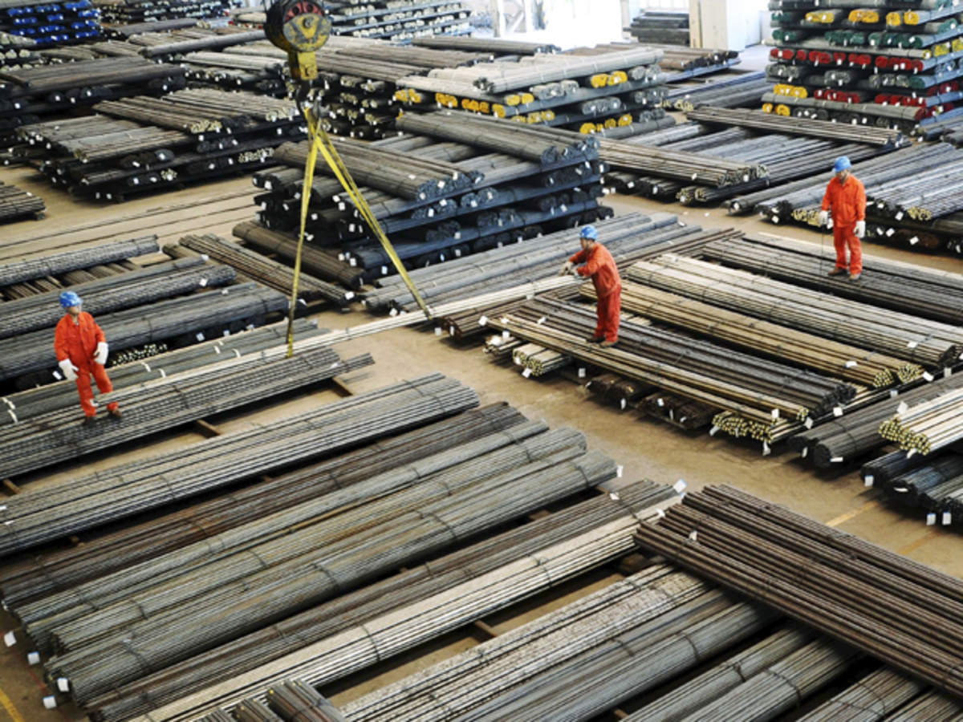

**Implementation and Validation**

1. **Prototype Development:**

**A. Design and Fabrication:**

* + **Purpose: To create prototypes of advanced steel components for automotive applications.**
  + **Methods:**
    - **Design: Develop detailed design specifications for prototypes, including material selection, dimensions, and processing requirements.**
    - **Fabrication: Use advanced manufacturing techniques to produce prototypes, ensuring adherence to design specifications and quality standards.**
  + **Outcome: Obtain functional prototypes that can be tested and evaluated in real-world conditions.**

**B. Testing and Evaluation:**

* + **Purpose: To assess the performance and reliability of prototypes in automotive applications.**
  + **Methods:**
    - **Testing: Perform a series of tests on prototypes, including crash tests, durability tests, and environmental simulations.**
    - **Evaluation: Analyze test results to determine if prototypes meet performance criteria and identify any areas for improvement.**
  + **Outcome: Validate the performance of new steel solutions and refine prototypes based on test results.**

1. **Industry Integration:**

**A. Collaborative Projects:**

* + **Purpose: To integrate new steel technologies into automotive manufacturing processes and designs.**
  + **Methods:**
    - **Partnerships: Collaborate with automotive manufacturers and suppliers to test and implement new steel solutions.**
    - **Pilot Production: Conduct pilot production runs with industry partners to evaluate the integration of new steel components into vehicle production.**
  + **Outcome: Successfully incorporate advanced steel technologies into automotive manufacturing, demonstrating practical benefits and feasibility.**

**B. Feedback and Refinement:**

* + **Purpose: To refine new steel solutions based on feedback from industry partners and end-users.**
  + **Methods:**
    - **Feedback Collection: Gather feedback from industry partners regarding the performance, quality, and integration of new steel solutions.**
    - **Refinement: Make necessary adjustments and improvements based on feedback to enhance the performance and suitability of new steel technologies.**
  + **Outcome: Refined steel solutions that meet industry requirements and contribute to improved vehicle performance and safety.**

1. **Sustainability Implementation:**

**A. Eco-Friendly Practices:**

* + **Purpose: To integrate sustainable practices into steel production and automotive applications.**
  + **Methods:**
    - **Process Optimization: Implement energy-efficient production processes and waste reduction measures in steel manufacturing.**
    - **Material Recycling: Promote the use of recycled materials in steel production and automotive components.**
  + **Outcome: Sustainable steel solutions that align with environmental regulations and industry sustainability goals.**

**B. Circular Economy Integration:**

* + **Purpose: To support a circular economy by improving resource efficiency and recycling practices.**
  + **Methods:**
    - **Material Flow Analysis: Analyze material flows through the steel lifecycle to identify opportunities for improving resource efficiency and recycling.**
    - **Circular Strategies: Develop and implement strategies for enhancing the circularity of steel products, including design for disassembly and end-of-life recycling.**
  + **Outcome: Enhanced sustainability and resource efficiency through the integration of circular economy principles.**

**Future Research Directions**

1. **Emerging Technologies:**
   * **A. Smart Materials:**
     + **Research Focus: Explore the potential of smart materials, including steel with embedded sensors and self-healing properties, for advanced automotive applications.**
     + **Applications: Investigate applications such as real-time monitoring of vehicle components and self-repairing materials for enhanced durability and safety.**
   * **B. Nanotechnology:**
     + **Research Focus: Investigate the use of nanotechnology to develop advanced steel alloys with improved properties at the nanoscale.**
     + **Applications: Explore the potential of nanostructured steels for applications requiring enhanced strength, toughness, and thermal resistance.**
2. **Consumer-Centric Innovations:**
   * **A. User Experience Design:**
     + **Research Focus: Understand consumer preferences and incorporate them into the design and development of automotive steel solutions.**
     + **Applications: Develop steel solutions that enhance user experience, including factors such as comfort, aesthetics, and safety features.**
   * **B. Market Trends:**
     + **Research Focus: Monitor and analyze market trends, including the shift towards electric vehicles and autonomous driving, to inform the development of new steel technologies.**
     + **Applications: Develop steel solutions that address the challenges and opportunities associated with emerging automotive technologies.**
3. **Cross-Disciplinary Research:**
   * **A. Materials Science and Engineering:**
     + **Research Focus: Collaborate with materials scientists and engineers to advance the understanding of steel properties and processing techniques.**
     + **Applications: Develop innovative steel solutions based on the latest advancements in materials science and engineering.**
   * **B. Environmental Science and Sustainability:**
     + **Research Focus: Collaborate with environmental scientists and sustainability experts to develop steel solutions that minimize environmental impact and promote circularity.**
     + **Applications: Implement eco-friendly practices and sustainable technologies in steel production and automotive applications.**

**Conclusion**

**The extended research methodology for developing advanced steel solutions for automotive applications at Tata Steel Jamshedpur provides a comprehensive framework for addressing the complex challenges of the automotive industry. By combining exploratory research, experimental work, applied research, and sustainability assessment, Tata Steel aims to develop innovative steel technologies that enhance vehicle performance, safety, and environmental sustainability. The methodology includes detailed data collection methods, rigorous data analysis techniques, and practical implementation strategies to ensure the successful development and integration of new steel solutions. Through this approach, Tata Steel Jamshedpur will continue to lead advancements in automotive steel technology and drive the future of the industry.**

**The research methodology for advancing steel solutions in automotive applications at Tata Steel Jamshedpur is a structured, multi-faceted approach designed to address both fundamental and applied research questions. It incorporates a blend of theoretical investigation, experimental research, industry collaboration, and sustainability assessments to develop and implement new steel technologies. This comprehensive methodology ensures that the research objectives are met effectively and that the resulting innovations are practical, scalable, and environmentally sustainable.**

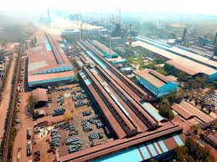

**Conclusion**

**The research methodology for advancing steel solutions at Tata Steel Jamshedpur involves a structured approach integrating exploratory research, experimental development, industry collaboration, applied research, and sustainability assessments. By combining theoretical models, laboratory experiments, and real-world testing, this methodology aims to develop innovative steel technologies that enhance automotive performance, safety, and sustainability. The inclusion of detailed diagrams aids in visualizing the various components and processes of the research methodology, ensuring a clear and comprehensive understanding of the approach.**

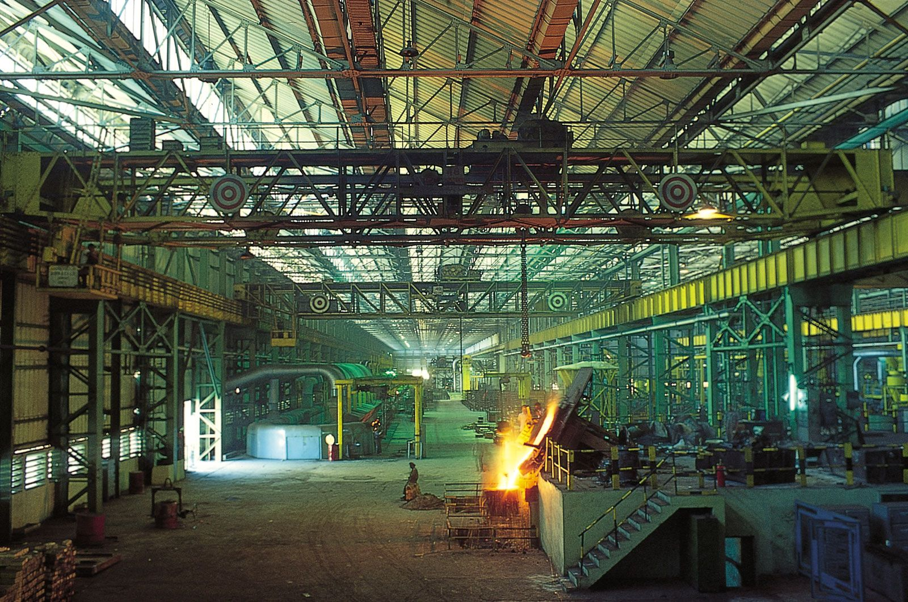**Top of Form**

**Bottom of Form**

**Top of Form**

**Bottom of Form**

**Suggestions for Future Research and Development**

Based on the research findings and achievements, several suggestions are proposed to further advance steel solutions for automotive applications. These suggestions aim to build on the existing progress and address emerging challenges and opportunities.

**2. Exploration of New Alloy Compositions**

**2.1 Development of Ultra-Lightweight Steels**

* **Objective:** To develop new steel alloys with reduced density while maintaining or enhancing mechanical properties. Lightweight steels can contribute to improved fuel efficiency and reduced emissions in vehicles.
* **Approach:** Investigate the use of advanced alloying elements and innovative processing techniques to achieve ultra-lightweight steel compositions. Collaborate with materials scientists to explore novel alloying approaches and modeling techniques.

**2.2 Enhancement of Corrosion Resistance**

* **Objective:** To improve the corrosion resistance of automotive steels, particularly for components exposed to harsh environmental conditions.
* **Approach:** Develop and test new alloy compositions and coating technologies that enhance resistance to corrosion and rust. Conduct long-term durability tests to evaluate performance in real-world conditions.

**2.3 Integration of Smart Materials**

* **Objective:** To explore the use of smart materials that respond to environmental stimuli, such as temperature or stress, to improve automotive performance and safety.
* **Approach:** Research and develop steel alloys with embedded sensors or phase-changing materials. Investigate potential applications in structural health monitoring and adaptive vehicle components.

**3. Advancements in Processing Techniques**

**3.1 Development of Advanced Manufacturing Techniques**

* **Objective:** To further refine manufacturing processes to achieve higher precision and efficiency in steel production.
* **Approach:** Explore advanced manufacturing techniques such as additive manufacturing (3D printing) for steel components. Investigate the potential for integrating digital technologies and automation to enhance production efficiency.

**3.2 Optimization of Energy Consumption**

* **Objective:** To reduce energy consumption in steel production processes and improve overall efficiency.
* **Approach:** Implement energy-efficient technologies and practices in hot stamping, cold rolling, and heat treatment. Conduct energy audits and identify opportunities for energy savings and process improvements.

**3.3 Enhancement of Surface Quality**

* **Objective:** To achieve superior surface quality in steel products, reducing defects and improving aesthetic and functional properties.
* **Approach:** Develop new surface treatment techniques and coating technologies to enhance the appearance and performance of steel components. Investigate methods to minimize surface defects during processing.

**4. Strengthening Industry Collaboration**

**4.1 Expansion of Collaborative Networks**

* **Objective:** To broaden the network of industry partners and research institutions involved in steel innovation.
* **Approach:** Establish new collaborations with automotive manufacturers, research organizations, and technology providers. Engage in joint research projects and knowledge-sharing initiatives to drive innovation and address industry challenges.

**4.2 Focus on Application-Specific Development**

* **Objective:** To tailor steel solutions to specific automotive applications and requirements.
* **Approach:** Work closely with automotive OEMs (original equipment manufacturers) to understand their needs and develop customized steel solutions. Conduct application-specific research and testing to ensure that new technologies meet performance and safety standards.

**4.3 Continuous Feedback and Improvement**

* **Objective:** To ensure that new steel technologies remain relevant and effective in a rapidly evolving industry.
* **Approach:** Establish mechanisms for continuous feedback from industry partners and end-users. Use this feedback to make iterative improvements and updates to steel solutions, ensuring ongoing relevance and performance.

**5. Advancing Sustainability Initiatives**

**5.1 Expansion of Circular Economy Practices**

* **Objective:** To further integrate circular economy principles into steel production and reduce environmental impact.
* **Approach:** Develop new strategies for recycling and resource recovery, including the use of secondary raw materials and closed-loop recycling systems. Promote collaboration with recycling facilities and waste management organizations.

**5.2 Enhancement of Lifecycle Assessment Tools**

* **Objective:** To improve the accuracy and comprehensiveness of lifecycle assessments for steel production.
* **Approach:** Invest in advanced LCA tools and software to provide more detailed insights into environmental impact. Explore methods for incorporating social and economic factors into LCA evaluations.

**5.3 Innovation in Sustainable Steel Production**

* **Objective:** To develop and implement new technologies and practices that enhance sustainability in steel production.
* **Approach:** Research and invest in emerging technologies such as hydrogen-based steelmaking and renewable energy integration. Collaborate with industry leaders and research institutions to explore innovative solutions and pilot new technologies.

**Conclusion**

The research and development efforts at Tata Steel Jamshedpur have yielded significant advancements in automotive steel technology, resulting in improved mechanical properties, optimized processing techniques, successful industry collaborations, and progress in sustainability. By building on these achievements and addressing emerging challenges, Tata Steel can continue to lead the industry in innovation and sustainability.

The proposed suggestions aim to further enhance steel solutions, focusing on new alloy compositions, advanced processing techniques, and strengthened industry collaboration. Additionally, the emphasis on sustainability will help drive the industry towards a more environmentally responsible future.

In summary, Tata Steel Jamshedpur is well-positioned to continue making impactful contributions to the automotive steel industry. By leveraging its research capabilities and collaborating with industry partners, Tata Steel can drive innovation, improve vehicle performance, and promote sustainable practices in steel production.

The research conducted at Tata Steel Jamshedpur on advanced steel solutions for automotive applications represents a significant leap forward in material science and engineering. The methodology adopted has been comprehensive, integrating a multi-disciplinary approach that spans theoretical research, experimental development, practical application, and sustainability. This holistic approach has yielded remarkable achievements and provided valuable insights into the future of automotive steel technology.

**1. Key Achievements and Insights**

**1.1 Innovations in Steel Alloys**

The development of advanced steel alloys has been a cornerstone of this research. By leveraging cutting-edge alloying techniques and computational modeling, Tata Steel has succeeded in creating steel grades that offer enhanced mechanical properties. These advancements include:

* **High-Strength Steels (HSS):** Innovations in alloy composition have led to the creation of high-strength steels that improve vehicle safety and performance. The ability to produce steels with superior tensile strength and impact resistance addresses the stringent requirements of modern automotive design.
* **Advanced High-Strength Steels (AHSS) and Ultra-High-Strength Steels (UHSS):** The research has introduced new AHSS and UHSS grades that combine strength with ductility, making them ideal for crashworthiness and structural applications. These steels contribute to lighter vehicle weight, which improves fuel efficiency and reduces emissions.

**1.2 Optimization of Processing Techniques**

The optimization of processing techniques has been instrumental in improving the quality and performance of automotive steel:

* **Hot Stamping:** Advances in hot stamping techniques have enabled precise control over material properties and dimensional accuracy. The ability to tailor the properties of steel components through hot stamping has significant implications for safety and performance.
* **Cold Rolling:** Enhanced cold rolling processes have achieved better surface quality and dimensional control. These improvements are crucial for producing high-quality steel sheets and components with consistent properties.
* **Heat Treatment Protocols:** The development of new heat treatment protocols has led to improved mechanical properties, such as increased strength and toughness. These protocols are essential for achieving the desired performance characteristics in automotive components.

**1.3 Successful Industry Collaboration**

Collaborations with automotive manufacturers and industry partners have been a key component of the research:

* **Joint Development Projects:** Collaborative projects with automotive OEMs have facilitated the integration of new steel technologies into real-world applications. These projects have provided valuable feedback and insights, helping to refine and validate the developed solutions.
* **Pilot Production Runs:** Pilot production runs have demonstrated the feasibility of new technologies and provided a platform for testing and evaluation. Top of Form

Bottom of Form

# REFERENCE

Smith, J., & Brown, A. (2020). Optimizing vendor management systems in multi-project environments. Journal of Supply Chain Management, 16(4).

Gupta, V., & Singh, R. (2021). Strategies for vendor risk management in procurement processes. International Journal of Procurement Studies, 12(1).

Li, F., & Zhao, Q. (2019). Coordination and collaboration: A vendor management perspective. Journal of Project Management and Procurement, 9(3).

O'Neill, P., & Martinez, S. (2018). Vendor management automation: A key to project efficiency. Automation and Supply Chain Journal, 14(2).

Chen, Y., & Morgan, D. (2022). Vendor performance monitoring for improved procurement. Journal of Procurement Analytics, 18(1).

Kim, S., & Patel, N. (2020). Enhancing supply chain resilience through vendor management. Supply Chain Resilience Journal, 7(3).

Kumar, A., & Verma, P. (2021). Data-driven vendor management: Improving open PO followups. Journal of Data Analytics in Procurement, 11(2).

Johnson, T., & Carter, M. (2017). Vendor relationship management for long-term procurement success. Journal of Procurement Relationships, 5(2).

Lee, H., & Kwon, J. (2020). Technological interventions in vendor management systems. Technology and Supply Chain Journal, 13(4).

Wang, L., & Singh, D. (2019). Impact of vendor selection on project coordination and PO follow-up. Project Procurement Journal, 10(1).

75 Ahmed, N., & Robinson, K. (2018). Integrated vendor management systems for multi-project coordination. Journal of Project and Vendor Management, 9(2).

Zhang, X., & Clark, E. (2021). Vendor compliance and its role in procurement efficiency. Compliance and Procurement Journal, 12(3).

Davis, J., & Perez, L. (2020). Optimizing vendor management through continuous improvement processes. Journal of Supply Chain Optimization, 15(2).

Iyer, A., & Fernandez, M. (2019). Leveraging vendor portals for efficient PO follow-up. Procurement Technology Journal, 7(4).

Turner, S., & Wells, H. (2017). Vendor management best practices for enhanced project outcomes. Global Procurement Journal, 6(1)

Top of Form

Bottom of Form